**1. INTRODUCTION**

**1.1 GENERAL INTRODUCTION**

One of the Major contribution of the 21th century is computer is being used in almost every field of life one cannot think about a world without computer. There has been a rapid and widespread growth in every sphere of the life due to the arrival of the computers. They are very much reliable and that is why they are favorites of men in almost every department or section of work. They are indispensable to engineers, scientists, managers, business executives, administrators, accountants, teachers, students they have strengthened man’s power in numerical computations and information processing and here by increasing the effectiveness of the organization.

**“Online Private Tutor Finder System”** is a **“Private Tuition Website”**, is a flexible web-based platform and will be very useful for students who are facing academic challenges. This application is developed in programming platform of PHP and MySQL for managing databases.

**1.2 PROBLEM STATEMENT**

Our proposed online private tutor finder system is an online tuition application that enables ease for students/parents. It overcomes the disadvantage of the traditional tuition system. The “Tutor Finder” system is to assist the students/parents in interactively finding private tutors. It aims to complement the efforts of a student to find a desirable tutor. The existing manual system based on finding a tutor for students is a very time-consuming and tiring process for the students. As technology advances, so do private tutoring options, and online tutoring programs exist alongside traditional ones. It’s not a surprise because online education is becoming increasingly popular. Online tutoring offers a lot more flexibility and convenience than traditional tutoring. There is no need to commute, and it can be done from virtually anywhere as long as your child has access to the internet.  So, even if you are traveling, your child does not need to skip a tutoring session.

Moreover, online tutoring offers wider tutor and course options. So, you can get access to qualified and experienced tutors and diverse course options that may not be available in your location. Since online tutoring platforms hire distance teachers, they do not need to cover overhead costs. Thus, in many cases, you can expect lower fees.

**1.3 OBJECTIVE OF THE PROJECT**

The main objective of this project is to help students overcome academic challenges and lead them to autonomous or independent learning. It is a special kind of teaching that is different from the teaching performed by teachers, friends, and parents. You offer students one-on-one attention, individualized explanation, and a chance to ask as many question as they like in a non-judgmental atmosphere.

* To design a system that can provide a way to make class outside classroom.
* To design a system that can allow users to connect any tutor with thousands of professional and certification at one place.
* More regular contacts with your tutor.
* Its cost effective than traditional one.
* To develop a platform for student to find tutor outside the class based on subject they need more attention.
* To test the capabilities of the Tutor Finder system useful to the user based on review by users.

**1.4 SOFTWARE INTRODUCTION**

**1.4.1 FRONT-END: PHP**

The system is intended to work in an intranet environment. PHP is a freeware. It is also a weakly typed, free form language .PHP has since evolved into a powerful server-side markup language with syntax that resembles a mix between Perl and C. PHP (Hypertext Preprocessor) is a server-side scripting language designed specifically for the Web. Within an HTML page, we can embedded PHP code that will be executed each time the page is visited.HTML generates the web page with the static text and images. However the need evolved for dynamic web based application, mostly involving database usage. These dynamic usage is facilated by PHP. Other tasks that PHP is especially good at are database access, disk access, networking and text manipulation. PHP is an excellent alternative to such similar programming solutions as Microsoft’s proprietary scripting engine ASP.PHP is a cross-platform and easy. Plus PHP adds features to solve common problems that programmers often encounter when programming for the web.

**1.4.2 BACK-END: MySQL**

Backend is the most important part in the working of the system. It is the back end that manages all the data. So it should be capable of managing, manipulating, protected data

and provides sufficient security for an authorized access of database. Considering the above said requirements we have wide range of products available in the market such as Oracle, Oracle8i, Microsoft access, Microsoft SQL server, MS Visual FoxPro, paradox, MySQL etc. and many server scripting languages like Perl, Python, PHP.

MySQL is free and open-source software under the terms of the GNU General Public License, and is also available under a variety of proprietary licenses. MySQL was owned and sponsored by the Swedish company MySQL AB, which was bought by Sun Microsystems (now Oracle Corporation). In 2010, when Oracle acquired Sun, Widenius forked the open-source MySQL project to create Maria DB. High Availability: Ensure business continuity with the highest levels of system availability through technologies that protect data against costly human errors and minimize disaster recovery downtime.

**2. LITERATURE SURVEY**

**2.1 INITIAL INVESTIGATION**

The system of private tuition has been in existence in India for a long time but in recent times it has grown manifold affecting the very core of educational system. Usually, when a student’s wants to search tutor, they have to search through newspaper advertisement or social media who can recommend a highly qualified and expert tutor with affordable fees. The process will take some time to the students to find the tutor. In order to counter the constraint, a private tutor through application has been proposed to find private tutor. The proposed work to make it easier for parents and students to instantly find and connect with thousands of professional and certified tutors at one place. The student can view and search the availability of the tutor based on the review that has been given by the other users. The learners with heterogeneous groups enable different professions, nationalities, and ages. The traditional system of education with visual classroom setup forces, books, tuition fees, together with the sum of the total huge money compared to online education. The system of modern education does not require any classroom setup or course book. Users can select the tutor and after selecting, users will raise the request of the demo lecture. After attending the lecture, they can book the tutor online .This application will provide students platform for finding the experts and tutors of their desired field/subject according to their qualification and experience. It also will help the users to search a good tutor instantly.

**3. ABOUT THE ORGANIZATION**

**3.1 OVERVIEW**

The establishment of St. Joseph’s College of Engineering, was the fulfillment of a long cherished dream of providing facilities for higher education to the people of the diocese and surrounding regions. The main objective is to develop a college with a distinct identity and character, where education and training are imparted in a truly Christian environment conducive to fostering Christian values such as faith in God, love for their fellow men and devotion to the motherland. Every facility is provided in the campus to create an environment fully conducive to realizing this objective.

Discipline, hard work, positive thinking, commitment to excellence and abiding faith in the Almighty are the guiding principles that propel the college to its vision of emerging as a Centre of Excellence in technical education in the country. Value systems such as eco-friendliness, quality consciousness and work ethics are also being instilled through the special work culture and campus life existing in the college.

The college aims to provide an education that WORKS! – An education that helps the students in ensuring a challenging and satisfying career after the course.

**3.2 VISION**

Developing into a world-class, pace-setting Institute of Engineering and Technology with distinct identity and character, meeting the goals and aspirations of the society.

**3.3 MISSION**

* To maintain a conducive infrastructure and learning environment for world class education.
* To nurture a team of dedicated, competent and research oriented faculty.
* To develop students with moral & ethical values, for their successful career by offering variety of programmes and services.

**3.4 OBJECTIVES**

St. Joseph’s College of Engineering and Technology, Palai was instituted with the objective of developing a center of professional learning with a distinct identity and character, for imparting education and training in a truly Christian environment, fostering Christian values of faith and love to God and fellowmen. The college aims to provide the kind of education that helps to achieve academic excellence and thereby ensures a challenging and satisfying career for the students on the successful completion of the programme. With this perspective, training is organized on a regular basis for the development of personality, learning and communication skills as well as employability skills.

**4. SYSTEM ANALYSIS**

System analysis is a structured method for identifying and solving problems. Analysis implies breaking something into its parts so that the whole may be understood. The definition of system analysis not only process analysis but also that of synthesis, which implies the process of putting parts together to form a new whole. All the activities relating to the life cycle phase must be performed managed and document. To design a system, we need requirements of the system and the specification document are prepared in this phase. The purpose of this document is to specify the functional requirement of the software that is to build. The specifications are intended to guide the activities, relationships and all other objectives.

The main thing is to find what is to be done to solve the problems with the current system. In the phase the problems or drawbacks of the current system is identified and the necessary actions to solve these problems are recommended.

**4.1 EXISTING SYSTEM**

In the present scenario, students have to physically visit the tuition centers for tuitions and have to make payments through cash mode most of the time due to unawareness of advanced technologies. In this method, time as well as physical work is required, among which time is something that no one has in ample amount. The existing manual system based on finding a tutor for students is a very time-consuming and tiring process for the students. Private tutoring is additional to school and usually takes place outside of school hours. Tuition normally takes place in the evenings or at the weekends. Tutors work with a variety of students, from those who are particularly struggling with areas of learning, to those who are looking for a challenge.  A private tutor will normally work with each student once or twice a week for around an hour. The traditional system of education with visual classroom setup forces, books, tuition fees, together with the sum of the total huge money compared to online education. Traditional education is more limited when it comes to educational formats. Sometimes pictures, videos or forums aren’t accessible 24/7. This feature might limit the learning and hinder a good study plan. And if the tuition centers are far, time is also a factor to take into account. You have to decide whether the travel is worth it or not.

**DISADVANTAGES OF EXISTING SYSTEM**

* In the traditional system need a lot of travel time and cost.
* High cost.
* Tutor may not be a good match.

**4.2 PROPOSED SYSTEM**

This system is a bunch of benefits from various points of view. This online application enables the end-users to register to the system online, select the subjects of their choice from the various tutors list. Also, the payment can be made through online mode. The proposed work has the common platform where the tutor and the user can access on their respective available views. In this application students can register and view the availability of the subject expert. Based on the user’s selection the slot of days and tutor will be blocked for their special classes and then they will be intimated through notifications. Teachers can also get a student just by logging onto the website and setting up the profile. In the personal tutor finder system, there are three entities namely, Admin, Users, and Tutor. Admin can login, manage tutor by adding new teachers and view all details about them. Admin can also verify and accept the registered tutors and users. Users can register and login; tutors can be viewed by users. Users can select the tutor and after selecting, users will raise the request of the demo lecture. After attending the lecture, they can book the tutor online. The tutor can login by using credentials and check for the request for a demo lecture and accept the request. They can also check the bookings done. This system provides the platform for online classes. This private tuition system can help the tutors to get students and parents to find the best tutors for their children.

**Admin**

Admin can handle the management of the tutor finder application. Manage the information of the tutor and registered parents of the system.

**User**

User can register and manage personal information. Find the tutor based on their own need. View tutor schedule and manage booking on the schedule. Also, student can manage feedback.

**Tutor**

The tutor needs to apply to become tutor in the system. Tutor also can manage profile, manage subject and schedule. Then, tutor can approved booking from student and view the demo video request also.

**4.2.1 ADVANTAGES OF THE PROPOSED SYSTEM**

* Elimination of travel time for both parents and tutors.
* Parents can get highly qualified tutors at affordable prices.
* Tutors share a wealth of knowledge, experience, and academic degrees which they have.
* **Learning takes place in a comfortable environment for your child.**
* **Online tutoring is cheaper than in-person tutoring.**

**4.2.2 FEATURES OF THE PROPOSED SYSTEM**

The various features of proposed system are as follows:

* Secure
* Easy to use
* Reliable and accurate
* No need to go to any places
* Smart search options
* Session transcripts and notes
* Real time notifications
* Extensive feedback system

**4.3 FEASIBILITY ANALYSIS**

System feasibility is a test or evaluation of the complete system plan. Such an evaluation is necessary to define the application area along with the extend and capability to provide the scope of computerization together with suggested output and input format and potential benefits. Feasibility study is a proposal according to the workability, impact on the organization, ability to meet user’s needs and efficient use of resources. The feasibility study is conducted to determine if the proposed system is feasible or not. Feasibility analysis evaluates the candidate systems and determines the best system that needs performance requirements. The purpose of feasibility study is to investigate the present system, evaluate the possible application of computer-based methods, select a tentative system, evaluate the cost and effectiveness of the proposed system, evaluate impact of the proposed system on existing personnel and ascertain the need for new personnel.

All projects are feasible when given unlimited resources and infinite time. It is both necessary and prudent to evaluate the feasibility of a project at the earliest possible time. A feasibility study is not warranted for systems in which economic justification is obvious, technical risk is low, few legal problems are expected and no reasonable alternative exists. An estimate is made of whether the identified user needs may be satisfied using current software and hardware technologies.

The study will decide if the proposed system will be cost effective from the business point of view and if it can be developed in the given existing budgetary constraints. The feasibility study should be relatively cheap and quick. The result should inform the decision of whether to go ahead with a more detailed analysis.

Feasibility study may be documented as a separated report to higher officials of the top-level management and can be included as an appendix to the system specification. Feasibility and risk analysis are related in many ways. If there is more project risk then the feasibility of producing the quality software is reduced.

The key combinations are involved in the feasibility study:

* Economic Feasibility
* Technical Feasibility
* Behavioral Feasibility
* Operational Feasibility.

**4.3.1 ECONOMICAL FEASIBILITY**

Economic analysis is the most frequently used method for evaluating the effectiveness of a candidate system which is known as cost benefit analysis. In cost benefit analysis, the benefits and savings that are expected from candidate systems compared with costs. If benefits outweigh cost then the decision is made to design and implement a system. Otherwise further justifications or alterations in the proposed system will have to be made if it has to be approved.

This project aims at reducing time, effort and cost for web masters. The system is developed under optimal expenses with the hardware and software. The developed system is available free of cost. Anybody can get the benefit of the system by simply using it as a service. There is no additional cost for using or implementing the system. It can be used in windows-based system, and need not alter the current system configurations. This makes the system feasible economically. Besides it is good economic to insist in such a kind of software from the project manager’s point of view as the benefits over weighs the cost. The resources needed to run the above project should be less in cost, easily available and highly reliable. This is a cost-effective project because of its accuracy, fastness and user-friendly nature. It is only required to host the site in the intranet inside the corresponding software firm or organization. So, there will be no additional expenses to host the site.

**4.3.2 TECHNICAL FEASIBILITY**

* Does the necessary technology exist to do what is been suggested?
* Does the proposed equipment have the technical capacity for using the new system?
* Are there technical guarantees of accuracy, reliability and data security?

A study of function, performance and constraints may improve the ability to create an acceptable system. Technical feasibility is frequently the most difficult area to achieve at the stage of product engineering process. Considering that are normally associated with the technical feasibility include Development risk,

Resource availability, Technology. Technical feasibility study deals with the hardware as well as software requirements. Project requirement system must be functional and multi user one should be based on specific technology the system under study must be practical and platform independent. It should be compactable with all kind of existing system in industry and should not provide any overhead to user. Implementation of existing system does not require changing of the existing configure of the system.

**4.3.3 BEHAVIOURAL FEASIBILITY**

An estimate should be made of how strong a reaction the user staff is likely to have toward the development of a computerized system. It is common knowledge the computer installations have something to do understandable that the introduction of a candidate system requires special effort to educate, sell and train the staff on new ways of considering business. The behavior of the site plays an important role in the number of users accessing the Website. This is due to the fact that is a simple site is very easy and convenient to use as compared to complex ones. Anyone with the basic internet knowledge can easily use the system and get its benefits. Additional training is not required to work with it. This means that the system is feasible.

**4.3.4 OPERATIONAL FEASIBILITY**

Question that going to be asked are:

* Will the system be used if it developed and implemented?
* If there was sufficient support for the project from the management and from the users.
* Have the users been involved in planning and development of the project.
* Will the system produce poorer result in any respect or area?

This application can be implemented in an organization because there is adequate support from management and users. And application will be used by them since it doesn’t generate poorer results or problems in any area. Therefore, the implementation of this application is operationally feasible. Operational feasibility is concerned with human, organizational and political aspects. The issues considered are the job changes that will be brought about, the organizational structures that will be distributed and the new skills that will be required.

**4.4 SOFTWARE REQUIREMENT SPECIFICATION (SRS)**

The primary goal of the system analyst is to improve the efficiency of the existing system. For that study of specification of the requirement is very essential. For the development of the new system, a preliminary survey of the existing system will be conducted. An investigation is done whether the up gradation of the system into an application program could solve the problems and eradicate the inefficiency of the existing system.

The System Requirements Specification is based on the System Definition. The requirement specifications are primarily concerned with functional and performance aspect of a software product and emphasis are placed on specifying product characteristics implying how the product will provide those characteristics. One of the most difficult tasks is selecting software, once the system requirement is found out then we have to determine whether a particular software package fits for those system requirements.

**4.4.1 SYSTEM REQUIREMENTS (HARDWARE AND SOFTWARE)**

**HARDWARE SPECIFICATIONS**

|  |  |
| --- | --- |
| **Main Processor** | Intel Core i5 8th Gen |
| **RAM** | 8 GB |
| **Clock Speed** | 1.66 GHz |
| **Hard Disk Drive** | 1TB |

**SOFTWARE SPECIFICATIONS**

|  |  |
| --- | --- |
| **Operating System** | Windows 10 |
| **Web Browser** | Google Chrome |
| **Front-End** | HTML, CSS, PHP |
| **Back-end** | MySQL |
| **IDE** | Sublime |
| **Tool** | XAMPP |

**4.5 DATA FLOW DIAGRAM (DFD)**

A Data Flow Diagram (DFD) is a graphical representation of the flow of data through an information system, modeling its process aspects. Larry Constantine first developed the DFD as a way of expressing system requirements in a graphical form lead to module design. Often they are preliminary step used to create an overview of the system which can later be elaborated. DFDs can also be used for the visualization of data processing (structured design). So it is the starting point of design phase that functionally decomposes the requirements specifications down to the lowest level of detail. A DFD consists of a series of bubbles joined by lines and it’s also known as a “bubble chart”.

DFD Symbols:

* A system defined source or destination of data.
* An array identifies data flow, data in motion.
* A circle represents the process that transforms incoming data flow to outgoing data flow.
* An open rectangular is data store-data at rest or temporary repository of data.

The DFD is used to represent increasing information flow and functional details. A Level 0 DFD is called a fundamental system model represents the entire software elements as single bubble with input and output indicated by incoming and outgoing arrows respectively. Additional process and information flow parts are represented in the next level, i.e. Level 1 DFD. Each of the processes represented at Level 1 are sub functions of overall system depicted in the context model.

Any processes which are complex in Level 1 will be further represented into sub functions in the next level, in Level 2. Data Flow diagram is a means of representing a system at any level of detail with a graphic network of symbols showing data flows, data stores, data processes and data sources. The purpose of data flow diagram is to provide a semantic bridge between users and system developers. The diagram are graphical, eliminating thousands of words, logical representation, modelling what system does; hierarchical, showing systems at any level of details; and jargon less, allowing user understanding and reviewing. The goal of data flow diagram is to have a commonly understood model of a system. Data flow diagram area supported by other techniques of structured system analysis such as data structured diagrams, data dictionaries and procedure representing techniques such as decision tables, decision trees.

**CONTEXT LEVEL- LEVEL 0 DFD**

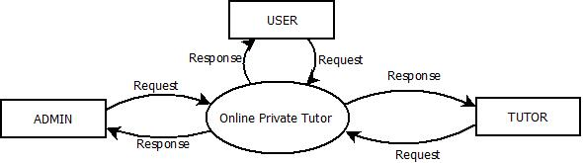

**Level 1 DFD for Admin**

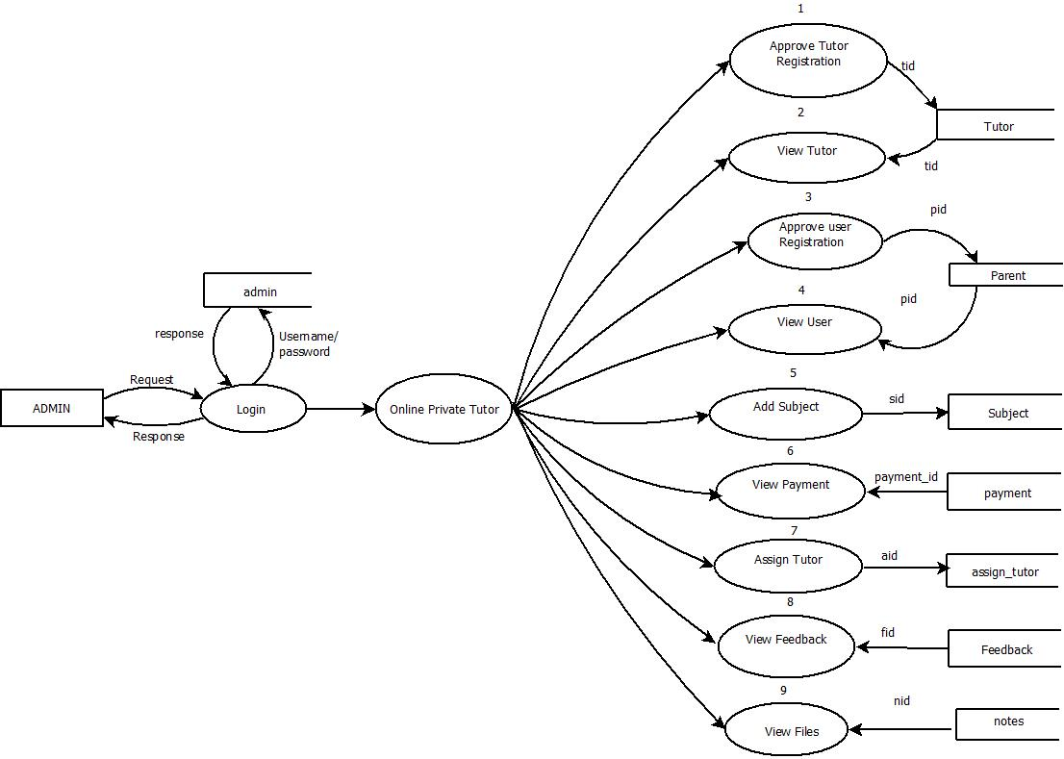

**Level 1 DFD for Tutor**

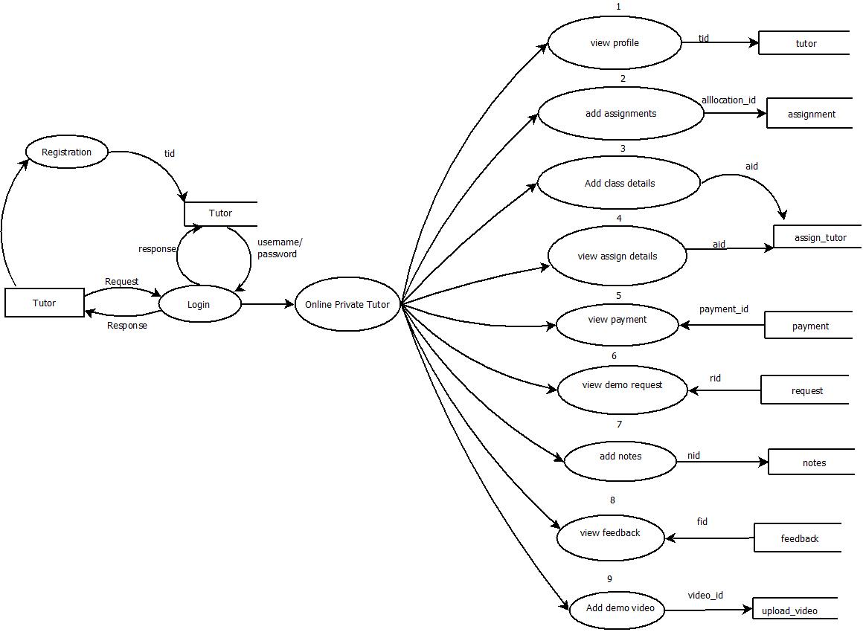

## 

## Level 1 DFD for User

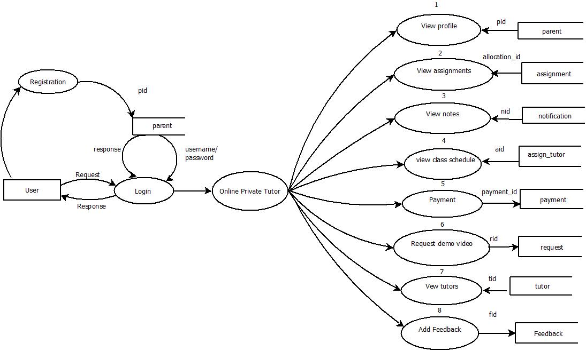

**5. TOOLS AND PLATFORMS**

**5.1 FRONT-END TOOL**

**PHP 5.6.25**

PHP is a scripting language designed to fill the gap between SSI (Server Side Includes)and Perl ,intended for the Web environment .Its principal application is the implementation of Web pages having dynamic content. PHP has gained quite a following in recent times, and it is one of the frontrunners in the Open Source software movement. Its popularity derives from its C-like syntax, and its simplicity. The newest version of PHP is 7.0 and it is heavily recommended to always use the newest version for better security, performance and of course features. Basically, PHP allows a static webpage to become dynamic.”**PHP: Hypertext Preprocessor**”. The word **“Preprocessor”** means that PHP makes changes before the HTML page is created. This enables developers to create powerful applications that can publish a blog , remotely control hardware, or run a powerful websites such as Wikipedia or Wiki books. Of course, to accomplish something such as this, you need a database application such as MySQL.

**HTML**

**Hypertext Markup Language** (HTML) is the standard markup language for documents designed to be displayed in a web browser. It can be assisted by technologies such as Cascading Style Sheet (CSS) and scripting languages such as JavaScript. Web browser receives HTML documents from a web server or from local storage and renders the documents into multimedia web pages. HTML describes the structure of a web page semantically and originally included cues for the appearance of the document. HTML can embed programs written in a scripting language such as JavaScript, which affects the behavior and content of web pages. Inclusion of CSS defines the look and layout of content. The World Wide Web Consortium (W3C).former maintainer of the HTML and current maintainer of the CSS standards, has encouraged the use of CSS over explicit presentational HTML since 1997. Hypertext Markup Language (HTML).

**5.2 BACK END TOOL**

**MySQL 5.7.14**

MySQL is free and open-source software under the terms of the GNU General Public License, and is also available under a variety of proprietary licenses. MySQL was owned and sponsored by the Swedish company MySQL AB, which was bought by Sun Microsystems (now Oracle Corporation). In 2010, when Oracle acquired Sun, Widenius forked the open-source MySQL project to create Maria DB. High Availability: Ensure business continuity with the highest levels of system availability through technologies that protect data against costly human errors and minimize disaster recovery downtime. Support can be obtained from the official manual. Free support additionally is available in different IRC channels and forums. Oracle offers paid support via its MySQL Enterprise products. They differ in the scope of services and in price. Additionally, a number of third party organizations exist to provide support and services, including MariaDB and Percona. MySQL has received positive reviews, and reviewers noticed it "performs extremely well in the average case" and that the "developer interfaces are there, and the documentation (not to mention feedback in the real world via Web sites and the like) is very, very good". It has also been tested to be a "fast, stable and true multi-user, multi-threaded sql database server".

**5.3 IDE**

**SUBLIME V3**

Sublime Text Editor is a full featured Text editor for editing local files or a code base. It includes various features for editing code base which helps developers to keep track of changes. Various features that are supported by Sublime are as follows −

* Syntax Highlight
* Auto Indentation
* File Type Recognition
* Sidebar with files of mentioned directory
* Macros
* Plug-in and Packages

Sublime Text editor is used as an Integrated Development Editor (IDE) like Visual Studio code and NetBeans. The current version of Sublime Text editor is 3.0 and is compatible with various operating systems like Windows, Linux and MacOS.

**Why Sublime Text?**

When you use a suitable Text editor, you can enjoy its rich beneficial features. Sublime Text offers its users the following benefits −

* Ability to solve linker errors.
* Keeping track of all files and folders to work with.
* Connectivity with version control systems like Git, Mercurial.
* Problem solving capabilities.
* Keeping color combination for syntax combination.

**6. SYSTEM DESIGN**

System design is the second phase of the software life cycle. The system goes through logical and physical state of development. The user-oriented performance specification is extended into a design specification, while designing the needed system. The design phase begins when the requirement specification document for the software to be developed is available. When the Requirement Specification activity is entirely in the problem domain, design is the first step to move from the problem domain to the solution domain. Design is essentially the bridge between the requirements specification and the final solution for satisfying these requirements.

Systems design is the process of defining the architecture, components, modules, interfaces, and data for a system to satisfy specified requirements. System design could be seen as the application of systems theory to product development. Computer software design changes continually as new methods, better analysis and broad understanding evolves. The design phase focuses on the detailed implementation of the system recommended in the feasibility study. Emphasis is on translating performance specification into design specification. The design phase is a transition from a user- oriented document to a document oriented to the programmers or data base administrator.

Software design methodology lacks the depth, flexibility, and quantitative nature that is normally associated with more classical engineering design disciplines. However, techniques for software design do exist, criteria for design quality are available design notation can be applied. Design is the only way that we can accurately translate computer’s requirements into a finished software product or system. Without design, we take risk in building an unusable system, one that will fail when small changes are made and one that will be difficult to test.

**6.1 INPUT DESIGN**

Input design is the process of converting a user-oriented description of the inputs to a computer- based business system into a programmer-oriented specification. The design decision for handling input specify how data are accepted for computer processing. Input design is a part of overall design that needs careful attention. The collection of input data is considered to be the most expensive part of the system design. Since the inputs have to be planned in such a way so as to get the relevant information, extreme care is taken to obtain the pertinent information. If the data going into the system is incorrect then the processing and outputs will magnify these errors. The goal of designing input data is to make data entry as easy, logical and free from errors as possible. The following are the objectives of input design:

* To produce a cost-effective method of input.
* To ensure validation.

Effort has been made to ensure that input data remains accurate from the stage at which it is recorded and documented to the stage at which it is accepted by the computer. Validation procedures are also present to detect errors in data input, which is beyond control procedures. Validation procedures are designed to check each record, data item or field against certain criteria.

In my proposed system of Student Information System, data has to be accurate and complete. If not, error messages are displayed to the user and he is unable to proceed to the next stage of action unless he corrects his data. Duplicate entries are not allowed. The data validation, a procedure of the proposed system, provides program checks for the completeness, consistency, reasonableness and sequence of the system.

Maximum care has been taken to ensure that user types in only minimum data into the system, as all he/she will have to do is to move and click the mouse or strike a key to select the desired data at the desired position.

The screens are designed in such a way that the user can find the needed like options, actions etc. with ease of use. The needed columns, where interaction is needed, like labels, buttons are also simple. The related data columns are clubbed together as groups, so that the user can understands the related data easily.

The input design is the link between the information system and the user. It comprises developing specifications and procedures for data preparation and those steps that are necessary to put input data into a usable form for processing data entry. The design of inputs focuses on controlling the number of inputs required, controlling errors, avoiding delay, avoiding extra steps and keeping the process simple.

**6.2 OUTPUT DESIGN**

The output design phase of the system design is concerned with the conveyance of information to the end users in user-friendly manner. The output design should be efficient, intelligible so that the system relationship with the end user is improved and thereby enhancing the process of decision making. The output design is an ongoing activity almost from the beginning of the project, efficient and well-defined output design improves the relation of the system and the user. The primary considerations in the design of the output are the requirement of the information and the objective of the end user. There are various

types of outputs required by most of the systems, but outputs of Student Information Website are purely interactive outputs-which involve the user in communicating with the computer.

The system output may be of any of the following:

* A report
* A document
* A notification

The output design specification is made in such a way that it is unambiguous and comprehensive. The approach to output design is very dependent on the type of output and nature of data. Special attention has to be made to data editing. The choice of appropriate output medium is also an important task. The output designed must be specified and documented, data items have to be accurately defined and arranged for clarity. The layout of the output will be normally specified on a layout chart. The final design layout must be approved by the user, communicated in detailed to the programmer. The user’s requirements are quite different from that of the programmer.

Before preparing a specification for the programmer, it is prudent to ensure that the design is acceptable to the user.

**6.3 TABLE DESIGN**

A database is a collection of interrelated data stored with minimum redundancy to serve many users quickly and efficiently. The general way is to make information as easy, quick, inexpensive and flexible for the user. In the database design several specific objectives are considered. Controlling the redundancy, ease of learning and use, data dependent, more information at low cost, accuracy and integrity are some of them.

**TABLE 1: ADMIN_LOGIN**

|  |  |  |  |
| --- | --- | --- | --- |
| **SL NO.** | **FIELD NAME** | **DATA TYPE** | **CONSTRAINTS** |
| 1 | admin_id | Int(11) | Primary Key |
| 2 | email | Varchar(50) | Not Null |
| 3 | password | Varchar(50) | Not Null |
| 4 | name | Varchar(50) | Not Null |

**TABLE 2: TUTOR_REGISTRATION**

|  |  |  |  |
| --- | --- | --- | --- |
| **SL NO.** | **FIELD NAME** | **DATA TYPE** | **CONSTRAINTS** |
| 1 | tid | Int(11) | Primary Key |
| 2 | name | Varchar(50) | Not Null |
| 3 | email | Varchar(50) | Not Null |
| 4 | password | Varchar(50) | Not Null |
| 5 | phone | Varchar(50) | Not Null |
| 6 | address | Varchar(250) | Not Null |
| 7 | qualification | Varchar(50) | Not Null |
| 8 | experience | Varchar(50) | Not Null |
| 9 | stream | Varchar(50) | Not Null |
| 10 | subject | Varchar(50) | Not Null |
| 11 | image | tinytext | Not Null |
| 12 | gender | Varchar(50) | Not Null |
| 13 | status | Varchar(50) | Not Null |
| 14 | rate | Varchar(50) | Not Null |
| 15 | assign | Varchar(50) | Not Null |

**TABLE 3: PARENT_REGISTRATION**

|  |  |  |  |
| --- | --- | --- | --- |
| **SL NO.** | **FIELD NAME** | **DATA TYPE** | **CONSTRAINTS** |
| 1 | pid | Int(11) | Primary Key |
| 2 | name | Varchar(25) | Not Null |
| 3 | email | Varchar(50) | Not Null |
| 4 | password | Varchar(25) | Not Null |
| 5 | address | Varchar(250) | Not Null |
| 6 | phone | Varchar(25) | Not Null |
| 7 | childname | Varchar(25) | Not Null |
| 8 | standard | Varchar(25) | Not Null |
| 9 | stream | Varchar(25) | Not Null |
| 10 | status | Varchar(25) | Not Null |
| 11 | Gender | Varchar(25) | Not Null |

**TABLE 4: ASSIGN_TUTOR**

|  |  |  |  |
| --- | --- | --- | --- |
| **SL NO.** | **FIELD NAME** | **DATA TYPE** | **CONSTRAINTS** |
| 1 | aid | Int(11) | Primary Key |
| 2 | tid | Int(11) | Foreign Key |
| 3 | tutor_name | Varchar(25) | Not Null |
| 4 | subject | Varchar(25) | Not Null |
| 5 | stream | Varchar(25) | Not Null |
| 6 | qualification | Varchar(50) | Not Null |
| 7 | start_time | Time(6) | Not Null |
| 8 | end_time | Time(6) | Not Null |
| 9 | class_date | date | Not Null |
| 10 | link | Varchar(250) | Not Null |
| 11 | meeting_no | BigInt(30) | Not Null |
| 12 | metting_password | Varchar(250) | Not Null |

**TABLE 5: ADD_SUBJECT**

|  |  |  |  |
| --- | --- | --- | --- |
| **SL NO.** | **FIELD NAME** | **DATA TYPE** | **CONSTRAINTS** |
| 1 | sid | Int(11) | Primary Key |
| 2 | subject | Varchar(25) | Not Null |
| 3 | standard | Varchar(25) | Not Null |

**TABLE 6: REQUEST**

|  |  |  |  |
| --- | --- | --- | --- |
| **SL NO.** | **FIELD NAME** | **DATA TYPE** | **CONSTRAINTS** |
| 1 | rid | Int(11) | Primary Key |
| 2 | tid | Int(11) | Foreign Key |
| 3 | pid | Int(11) | Foreign Key |
| 4 | subject | Varchar(25) | Not Null |
| 5 | standard | Varchar(25) | Not Null |
| 6 | childname | Varchar(50) | Not Null |
| 7 | status | Varchar(25) | Not Null |
| 8 | request_date | date | Not Null |

**TABLE 7: UPLOAD_VIDEO**

|  |  |  |  |
| --- | --- | --- | --- |
| **SL NO.** | **FIELD NAME** | **DATA TYPE** | **CONSTRAINTS** |
| 1 | video_id | Int(11) | Primary Key |
| 2 | tid | Int(11) | Foreign Key |
| 3 | name | Varchar(250) | Not Null |

**TABLE 8: NOTES**

|  |  |  |  |
| --- | --- | --- | --- |
| **SL NO.** | **FIELD NAME** | **DATA TYPE** | **CONSTRAINTS** |
| 1 | nid | Int(11) | Primary Key |
| 2 | tid | Int(11) | Foreign Key |
| 3 | subject | Varchar(25) | Not Null |
| 4 | notes | Varchar(250) | Not Null |
| 5 | file_type | Varchar(50) | Not Null |
| 6 | standard | Varchar(25) | Not Null |

**TABLE 9: ASSIGNMENT**

|  |  |  |  |
| --- | --- | --- | --- |
| **SL NO.** | **FIELD NAME** | **DATA TYPE** | **CONSTRAINTS** |
| 1 | allocation_id | Int(11) | Primary Key |
| 2 | tid | Int(11) | Foreign Key |
| 3 | pid | Int(11) | Foreign Key |
| 4 | subject | Varchar(25) | Not Null |
| 5 | standard | Varchar(25) | Not Null |
| 6 | pdate | Varchar(50) | Not Null |
| 7 | sdate | Varchar(50) | Not Null |
| 8 | uploadfile | Varchar(250) | Not Null |
| 9 | assignment | Varchar(250) | Not Null |

**TABLE 10: PAYMENT**

|  |  |  |  |
| --- | --- | --- | --- |
| **SL NO.** | **FIELD NAME** | **DATA TYPE** | **CONSTRAINTS** |
| 1 | payment_id | Int(11) | Primary Key |
| 2 | tid | Int(11) | Foreign Key |
| 3 | pid | Int(11) | Foreign Key |
| 4 | name | Varchar(25) | Not Null |
| 5 | amount | Varchar(25) | Not Null |
| 6 | pay_id | Varchar(250) | Not Null |
| 7 | pay_status | Varchar(50) | Not Null |
| 8 | date_added | datetime | Not Null |
| 9 | parent_name | Varchar(50) | Not Null |
| 10 | tutor_name | Varchar(50) | Not Null |

**TABLE 11: FEEDBACK**

|  |  |  |  |
| --- | --- | --- | --- |
| **SL NO.** | **FIELD NAME** | **DATA TYPE** | **CONSTRAINTS** |
| 1 | fid | Int(11) | Primary Key |
| 2 | tid | Int(11) | Foreign Key |
| 3 | pid | Int(11) | Foreign Key |
| 4 | parent_name | Varchar(25) | Not Null |
| 5 | subject | Varchar(25) | Not Null |
| 6 | standard | Varchar(50) | Not Null |
| 7 | childname | Varchar(50) | Not Null |
| 8 | feedback | Varchar(250) | Not Null |
| 10 | tutor_name | Varchar(50) | Not Null |

**6.4 PROCESS DESIGN**

A successful process design has to take into account the appropriateness of the process to overall organization objective. Process design requires a broad view of the whole organization and should not have a myopic outlook. And the process should deliver customer value with constant involvement of the management at various stages.

In order to achieve a good process design, effective process strategy is required, which deals with a singular line items required to manufacture the end product. Effective process strategy deals with raw material procurement, customer participation, technology investment, etc.

Over a period of time process design has undergone change and new concepts like flexible manufacturing systems have been developed, which delivers efficient and effective production design and analysis.

**6.4.1 MODULE DESCRIPTION**

**ADMIN**

* **Login:** Admin can login using credentials.
* **Manage Tutor:** Admin can view registered tutor and tutor’s
* **Manage Users:** Admin can view registered users and user’s information.
* **Add Subject and standard:** Admin can add subjects and standard.
* **View Payments:** Admin can view all payment details.
* **View Files:** Admin can view all lectures notes and files.
* **Assign Tutors:** Admin can assign tutors to different classes

**TUTOR**

* **Register:** Tutors can register and obtain credentials.
* **Login:** Tutors can login using credentials.
* **Manage Profile:** Tutors can manage their profile.
* **View User Request:** Tutors can view registered users request for demo videos.
* **Add Notes:** Tutors can add notes.
* **Add Demo Videos:** Tutors can add demo videos as per the user’s request.
* **Add Class Details:** Tutors can add all the details of class.
* **Add Assignment:** Tutors can upload assignments and view the assignment task done by the users

**USER**

* **Register:** Users can register and obtain credentials
* **Login:** Users can login using credentials.
* **View Tutor:** Users can check for tutors.
* **Request a Demo:** Users will select tutor and raise request for demo lecture.
* **Book a Tutor:** Users can book tutor
* **View Booked Tutor:** Users can check the booked tutor
* **Add Feedback:** Users can add feedback.
* **View Notification:** Users can view all the class schedules.
* **View Notes:** Users can view the notes added by the respective tutor.
* **View Assignment:** Users can view the assignments added by the respective tutor.

**7.** **SYSTEM TESTING**

**7.1 TESTING METHODOLOGIES AND STRATEGIES**

Software testing is an integral part of to ensure software quality, some software organizations are reluctant to include testing in their software cycle, because they are afraid of the high cost associated with the software testing. There are several factors that attribute the cost of software testing. Creating and maintaining large number of test cases is a time- consuming process. Furthermore, it requires skilled and experienced testers to develop great quality test cases.

Even with the wide availability of automation tools for testing, the degree of automation mostly remains at the automated test script level and generally significant amount of human intervention is required in testing. In addition, data collected, as testing is conducted provides a good indication of software quality as a while. The debugging process is the most unpredictable part of testing process. Testing begins at the module level and work towards the integration of entire computer-based system. No testing is completed without verification and validation part.

The goal of verification and validation activities are to access and improve the quality of work products generated during the development and modification of the software. Testing plays a vital role in determining the reliability and efficiency of the software and hence is very important stage in software development. Tests are to be conducted on the software to evaluate its performance under a number of conditions. Ideally, it should do so at the level of each module and also when all of them are integrated to form the completed system.

In the project **“Online Private Tutor Finder System”** the testing has been successfully handled with the modules. The test data was given to each and every module in all respect and got the desired output. Each module that has been tested is found working properly.

**7.1.1 UNIT TESTING**

Here we test each module individually and integrated the overall system. Unit testing focuses verification efforts even in the smallest unit of software design in each module. This is known as” module testing”. The modules of the **“Online Private Tutor Finder System”** are tested separately. This testing is carried out in the programming style itself. In this testing each module is focused to work satisfactorily as regard to expected output from the module. There are some validation checks for the fields. Unit testing gives stress on the modules of **“Online Private Tutor Finder System”** independently of one another, to find errors. Different modules are tested against the specifications produced during the design of the modules. Unit testing is done to test the working of individual modules with test servers. Program unit is usually small enough that the programmer who developed it can test it in a great detail. Unit testing focuses first on that the modules to locate errors. These errors are verified and corrected and so that the unit perfectly fits to the project.

**7.1.2 INTEGRATION TESTING**

Data can be lost across an interface, one module can have an adverse effect on the other sub-functions, when combined they may not perform the desired functions. Integrated testing is the systematic testing to uncover the errors within the interface. This testing is done with simple data and the developed system has run successfully with this simple data. The need for integrated system is to find the overall system performance.

After splitting the programs into units, the units were tested together to see the defects between each module and function. It is testing to one or more modules or functions together with the intent of finding interface defects between the modules or functions. Testing completed at as part of unit or functional testing, integration testing can involve putting together of groups of modules and functions with the goal of completing and verifying meets the system requirements.

**7.1.3 SYSTEM TESTING**

System testing focuses on testing the system as a whole. System Testing is a crucial step in Quality Management Process. In the Software Development Life Cycle, System Testing is the first level where the System is tested as a whole. The System is tested to verify whether it meets the functional and technical requirements. The application/System is tested in an environment that closely resembles the production environment where the application will be finally deployed.

The perquisites for System Testing are: -

* All the components should have been successfully Unit Tested.
* All the components should have been successfully integrated.
* Testing should be completed in an environment closely resembling the production environment. When necessary iterations of System Testing are done in multiple environments.

**7.1.4 USER ACCEPTANCE TESTING**

The system was tested by a small client community to see if the program met the requirements defined the analysis stage. It was fond to be satisfactory. In this phase, the system is fully tested by the client community against the requirements defined in analysis and design stages, corrections are made as required, and the production system is built. User acceptance of the system is key factor for success of the system.

**7.1.5 DATA VALIDATION TESTING**

Data validation is the process of testing the accuracy of data. A set of rule we can apply to a control to specify the type and range of data that can enter. It can be used to display error alert when users enter incorrect values in to a form. Now performing validation testing in system Centralized Social Welfare by undergoing validation for each tools and the validation succeeded when the software function in a manner that can be reasonably accepted, by the user.

**7.1.6 OUTPUT TESTING**

After performing validation testing the next step is to perform the output testing of the proposed system. Since no system could be useful if it does not produce required output in the specified format. The output generated are displayed by the user under consideration are tested by the company with the format required by the user. Here the output format is considered in two ways. One is onscreen and the other is printed format. The output format on the screen is found to be correct as the system design phase accounting to the user hence: the output testing does not result in any correction in the system.

**7.1.7 BLACK BOX TESTING**

Knowing the specified function that the product has been designed to perform, test can be conducted that each function is fully operational. Black box test is carried out to test that input to a function is properly accepted and output is correctly produced. A black box test examines some aspects of a system little regard for the internal structure of the software. Errors in the following categories were found through Black box testing:

* Incorrect or missing function.
* Interface errors.
* Errors in database structure or external database access.
* Performance errors
* Initialization and termination errors

**7.1.8 WHITE BOX TESTING**

White box testing of software is predicated on a close examination of procedural detail. The status of the project may be tested at various points to determine whether the exposed or asserted status is corresponding to the actual status.

Using these following test cases can be derived:

* Exercise all logical functions on their true and false side.
* Execute all loops within their boundaries and their operation bounds.
* Exercise internal data structure to ensure their validity.

**7.2 TESTING STRATEGIES**

**7.2.1 TOP-DOWN TESTING**

Top-Down Testing tests the higher levels of a system before testing its detailed components. The program is represented as a single abstract component with sub components represented by stubs. Stubs have the same interface as the components but very limits functionally. After the top- level component has been tested, its sub- components are implemented and tested in the same way. This process continues recursively until the bottom-level components are implemented. The whole system may then be completely tested.

**7.2.2 BOTTOM-UP TESTING**

Bottom-Up Testing is the converse of Top-Down Testing. It involves testing the modules at the lower levels of the hierarchy and then working up the hierarchy of the modules until the final module is tested. The advantage of bottom-up testing is the disadvantage of top-down testing and vice-versa. When using bottom-up testing test drivers must be written to exercise the lower level components. These test drivers simulate the components environment and are valuable components; the test drivers and test data should be distributed with the component. Potential re- users can then run these tests to satisfy themselves that the component behaves as expected in their environment.

**7.3 SAMPLE TEST CASES**

|  |  |  |  |
| --- | --- | --- | --- |
| **SL NO.** | **TEST CASE** | **MODULE** | **EXPECTED RESULT** |
| 1 | Verify whether an admin can log in to the system using his/her username and password. | Admin | Admin should be able to login the Admin module successfully. |
| 2 | Verify whether admin can approve/reject every users and tutor details. | Admin | As an admin user he/she should be able to approve/reject every users and tutor details. |
| 3 | Check whether an admin can assign, view and unassign tutor details. | Admin | Admin should be able to assign, view and unassign tutor details. |
| 4 | Verify whether a tutor can log in to the system using his/her username and password. | Tutor | Tutor should be able to login the Admin module successfully. |
| 5 | Check whether a tutor can view and edit their profiles | Tutor | Tutor should be able to view and edit profiles. |
| 6 | Check whether a tutor can add assignments. | Tutor | Tutor should be able to add assignments. |
| 7 | Check whether a tutor can upload demo videos. | Tutor | Tutor should be able to upload demo videos. |
| 8 | Verify whether tutor can add class details | Tutor | Tutor should be able to add class details |
| 9 | Check whether tutor can view payments. | Tutor | Tutor should be able to view payment details. |
| 10 | Check whether tutor can add notes | Tutor | Tutor should be able to add class notes |
| 11 | Verify whether user can log in to the system using his/her username and password. | User | User should be able to login the user module successfully. |
| 12 | Check whether a user can view tutors. | User | User should be able to view tutors. |
| 13 | Check whether a user can request demo videos. | User | User should be able to request demo videos. |
| 14 | Check whether a user can book tutors. | User | User should be able to book tutors. |
| 15 | Check whether a user can view notes and assignments. | User | User should be able to view notes and assignments. |

**8. SYSTEM IMPLEMENTATION**

Implementation includes placing the system into operation and providing the users and operation personnel with the necessary documentation to use and maintain the new system. Implementation includes all those activities that take place to convert from the old system to the new. The new system may be totally new, replacing an existing system. Proper implementation is essential to provide a reliable system to meet the organizational requirements. Successful implementation may not guarantee improvement in the organization using the new system, as well as, improper installation will prevent. There are four methods for handling a system conversion.

The Implementation Plan describes how the information system will be deployed, installed and transitioned into an operational system. The plan contains an overview of the system, a brief description of the major tasks involved in the implementation, the overall resources needed to support the implementation effort, and any site-specific implementation requirements. The plan is developed during the Design Phase and is updated during the Development Phase the final version is provided in the Integration and Test Phase and is used for guidance during the Implementation Phase.

The implementation phase ends with an evaluation of the system after placing it into operation of time. The validity and proper functionality of all the modules of the developed application is assured during the process of implementation. Implementation is the process of assuring that the information system is operational and then allowing user to take over its operation for use and evaluation. Implementation is the stage in the project where the theoretical design is turned into a working system. The implementation phase constructs, installs and operated the new system. The most crucial stage in achieving a new successful system is that it works effectively and efficiently.

There are three types of implementation:

* Conversion
* User training
* Documenting the system

**8.1 IMPLEMENTATION PROCEDURE**

Implementation is the process of personnel check out, install the required equipment and application and train user accordingly. Depending on the size of the organization and its requirements, the implementation is divided into three parts.

**8.1.1 STAGE IMPLEMENTATION**

Here system is implemented in stages. The whole system is not implemented at once. Once the user starts working with the system and is familiar with it, then a stage is introduced and implemented. Also, the system is usually updated, regularly until a final system is sealed.

**8.1.2 DIRECT IMPLEMENTATION**

The proposed new system is implemented directly and the user starts working on the new system. The shortcoming, if any, faced are then rectified later.

**8.1.3 PARALLEL IMPLEMENTATION**

The old and new systems are not used simultaneously. This helps in comparison of the results from two systems. Once the user is satisfied and his intended objectives are achieved by the new system, he stops using the old one.

**9. MAINTENANCE**

Once the system has been implemented, it cannot be considered as the end of the system life cycle. After the implementation it is necessary that the system be constantly monitored so that it may be decided as how the system is working. If any problem is encountered it is necessary that the in-charge person rectifies the problem so that the clients may not be affected by the problem. This phase of the system development life cycle is known as the maintenance period.

There are three types of maintenances:

* Correctives (fixing bugs/errors)
* Adaptive (updates due to environment changes)
* Perfective (enhancements, requirements change)

**10. CONCLUSION**

**“Online Private Tutor Finder System”** is a flexible platform that provides a better learning experience for the students who are facing academic challenges. Online tutoring system is one of the approaches used in today's private education which allows the tutors and students to communicate each other in a real time. The students agree the online learning give them flexibility on their learning compared to traditional learning. Tutor Finder System is a web application which focuses on student to find their tutor based on their specific needs.It eliminates the travel time for both users and tutors. Users can get highly qualified tutors at affordable prices. Online Tutoring provides a platform which has both audio and video options. And tutors can add lecture notes and e-book to their students. Online tutoring provides the supplemental skills-building that students require in a way that is significantly more cost-effective and convenient than traditional services.

**10.1 SCOPE FOR FUTURE ENHANCEMENTS**

The project will be very helpful in future. It saves time, effort and makes a better user friendly environment to all the users who use this project. Making enhancement is all about perfective maintenance. It means adding, modifying or redeveloping the code to support changes in the specification. It is necessary to keep up with changing user needs and the operational environment.

The following are the future scope for the project.

* Can be added email alert for registration.
* Can be added mock test.
* Can be added chatbot system.
* And many features can be added to this project to make it more robust.

**11. BIBLIOGRAPHY**

**11.1 REFERENCES**

1. Raghu Ramakrishnan and Johannes Gehrke, “Database Management System”, third edition, McGraw-Hill Professional Publication
2. Dave W Mercer, Allan Kent, Steven D Nowicki, David Mercer , Dan Squier,Wankyu Choi, “Beginning PHP”, Wiley Publishing,Inc
3. “Programming PHP”,Rasmus LerDorf and Kevin Tatore,Shroff Publishers & Distributors Pvt.Ltd

**11.2 WEBSITES**

* www.wikipedia.com
* www.mysql.com
* http://php.net/
* <http://www.w3schools.com>
* https://nevonprojects.com/
* <https://www.tutorialspoint.com>

**12. APPENDIX**

**12.1 APPENDIX-A:**  **SCREEN SHOTS**

**HOME PAGE**



**TUTOR REGISTRATION FORM**

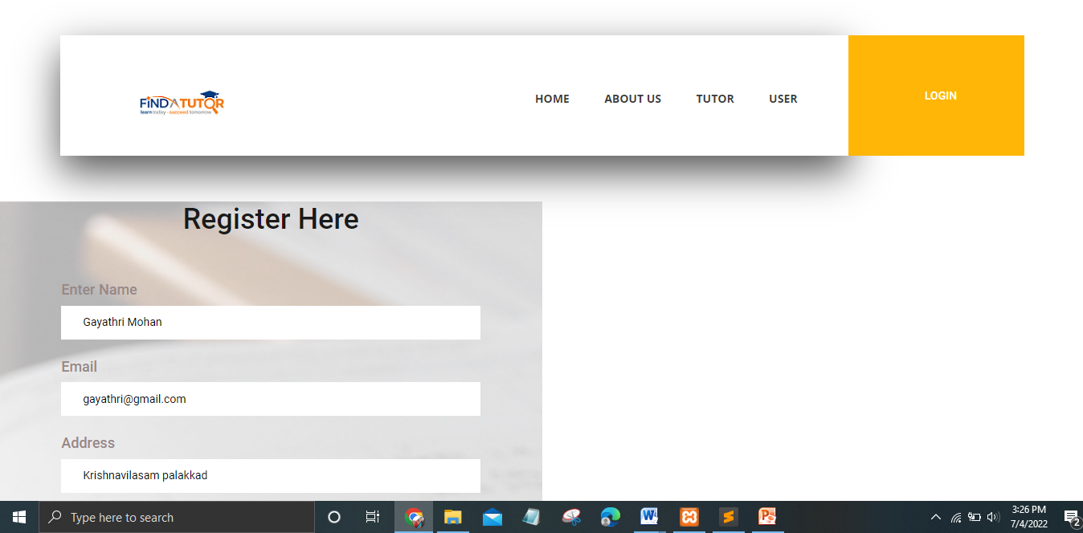

**USER REGISTRATION FORM**

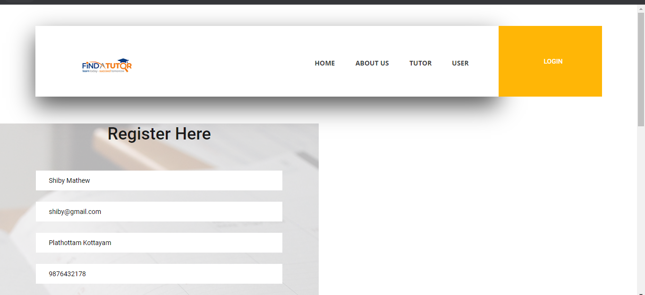

**LOGIN FORM**

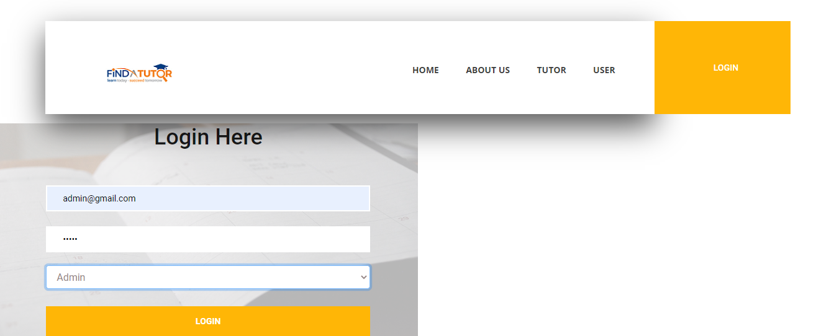

**ADMIN DASHBOARD**

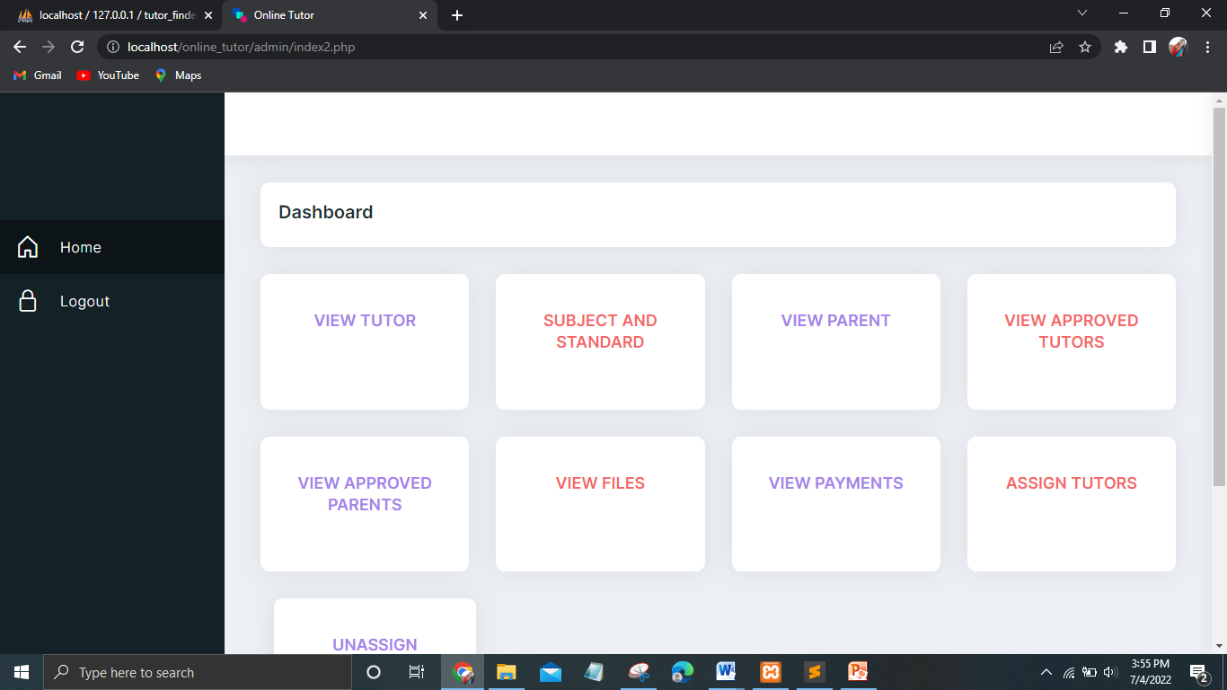

**VIEW REGISTERED TUTORS**

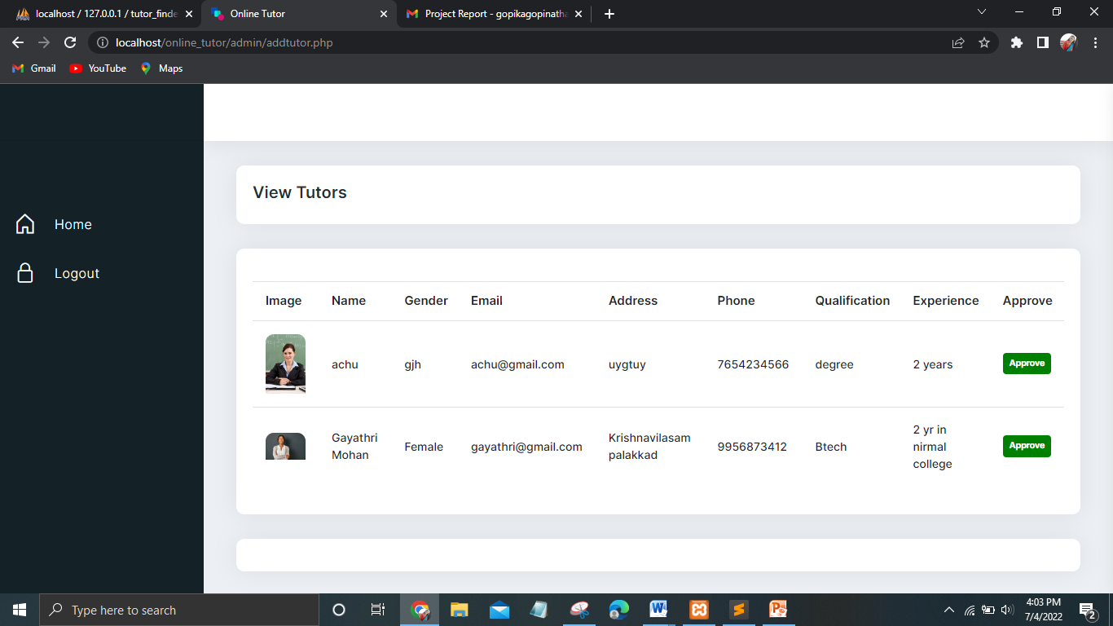

**VIEW REGISTERED PARENTS**

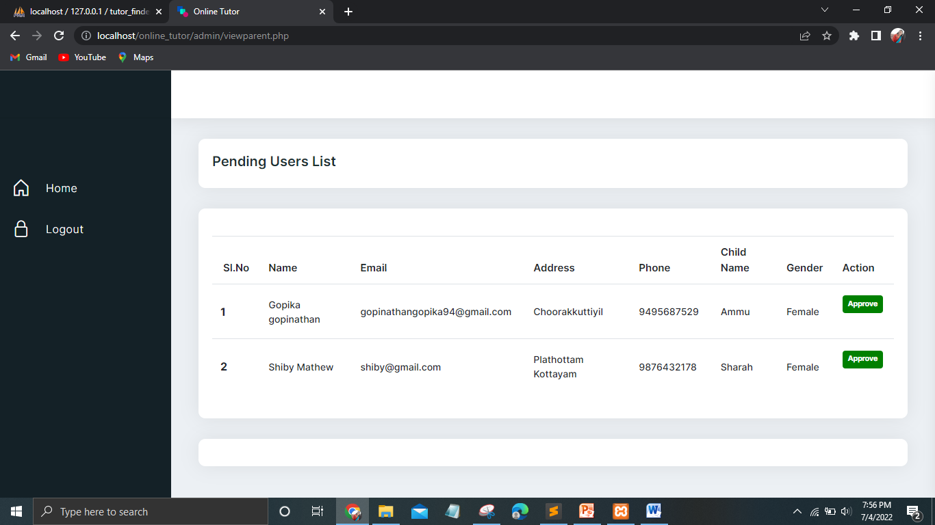

**VIEW APPROVED TUTOR LIST**

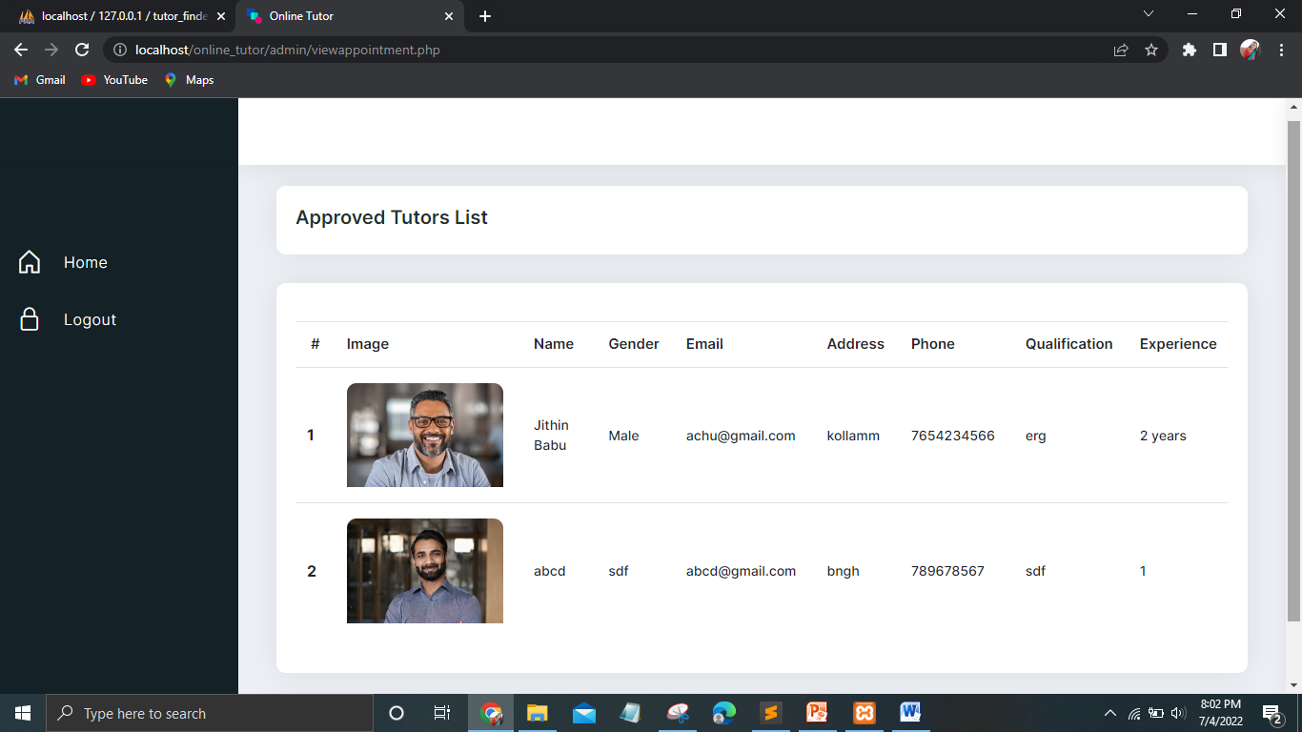

**VIEW APPROVED PARENT LIST**

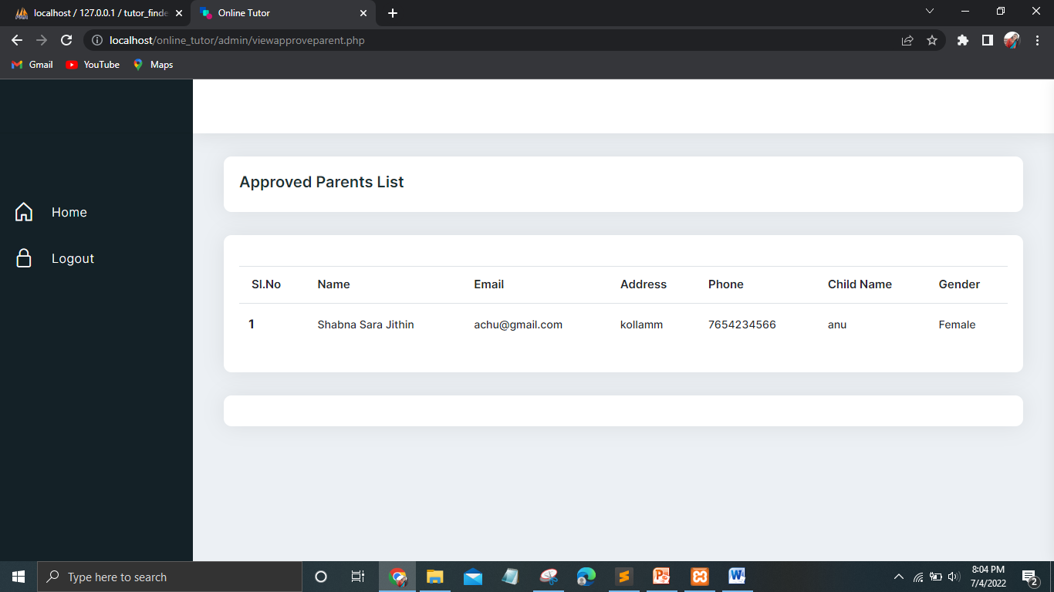

**ADD SUBJECTS**

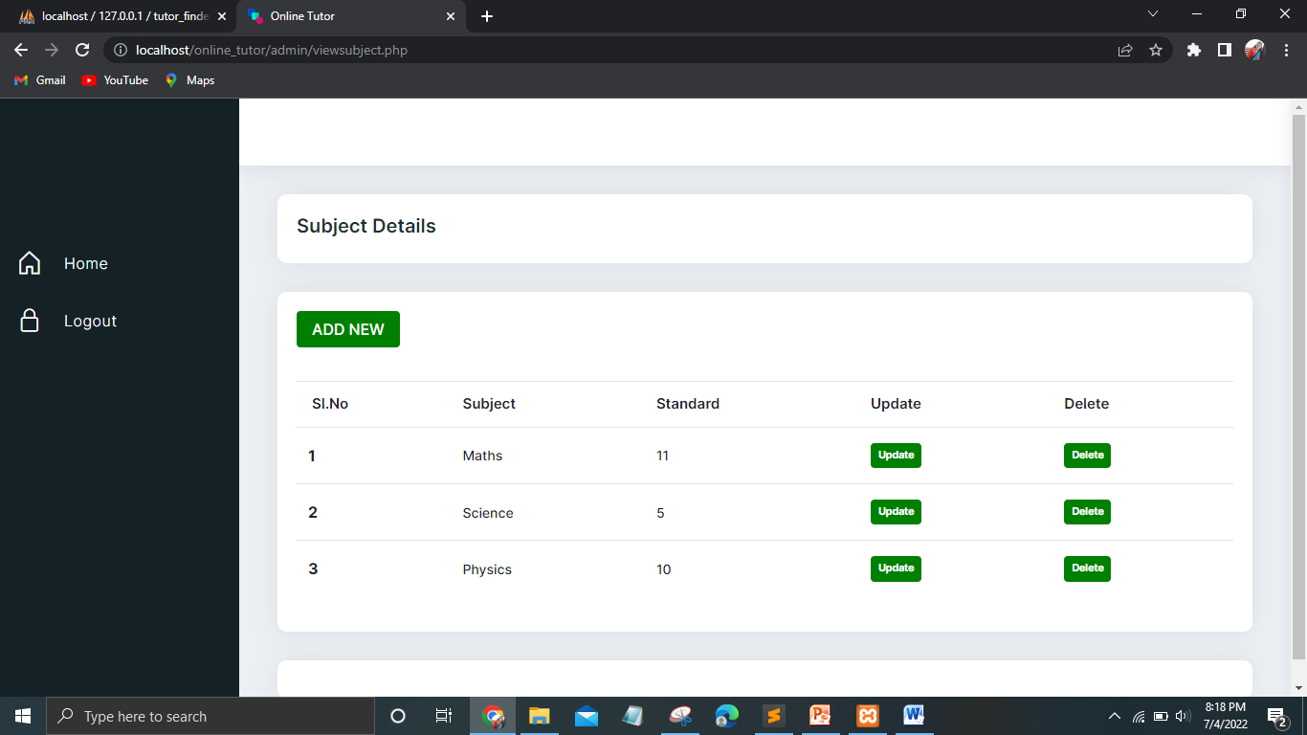

**VIEW FILES**

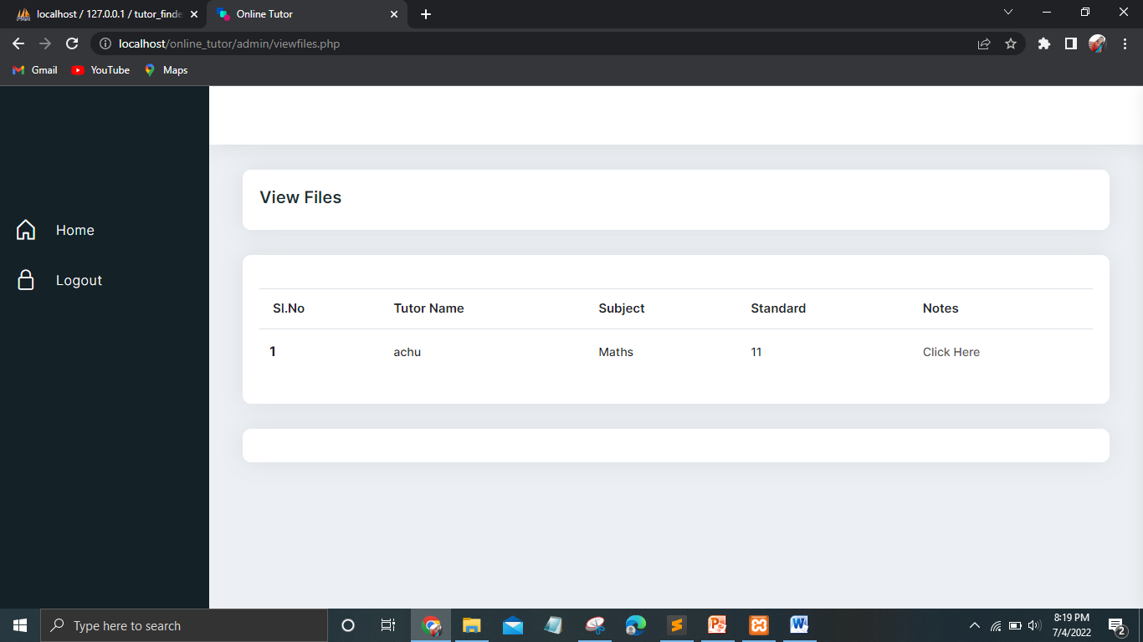

**VIEW PAYMENT DETAILS**

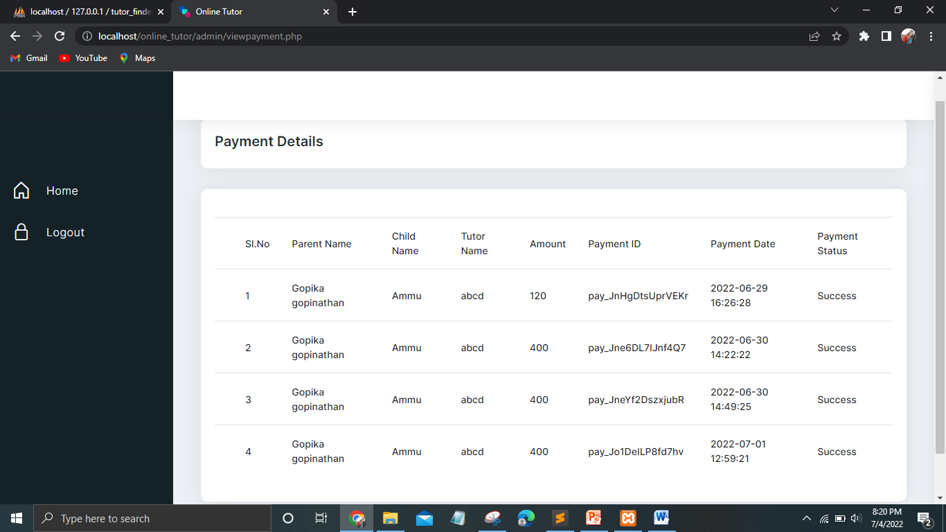

**ASSIGN TUTOR PAGE**

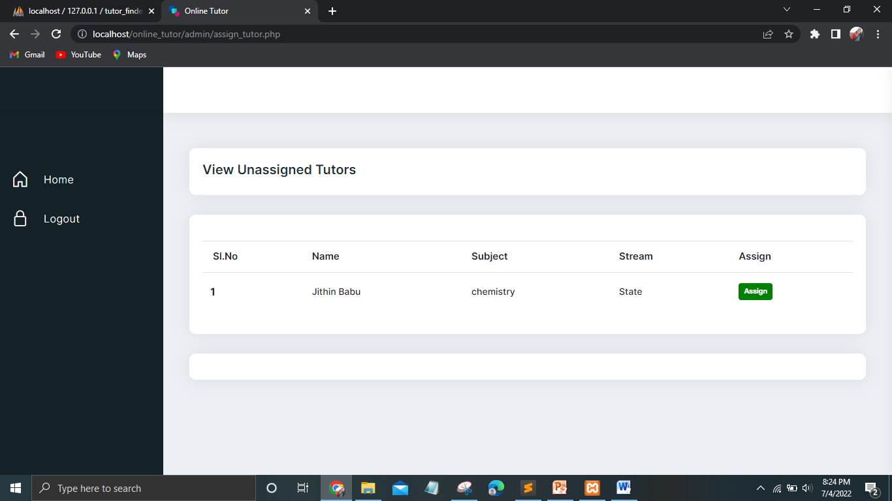

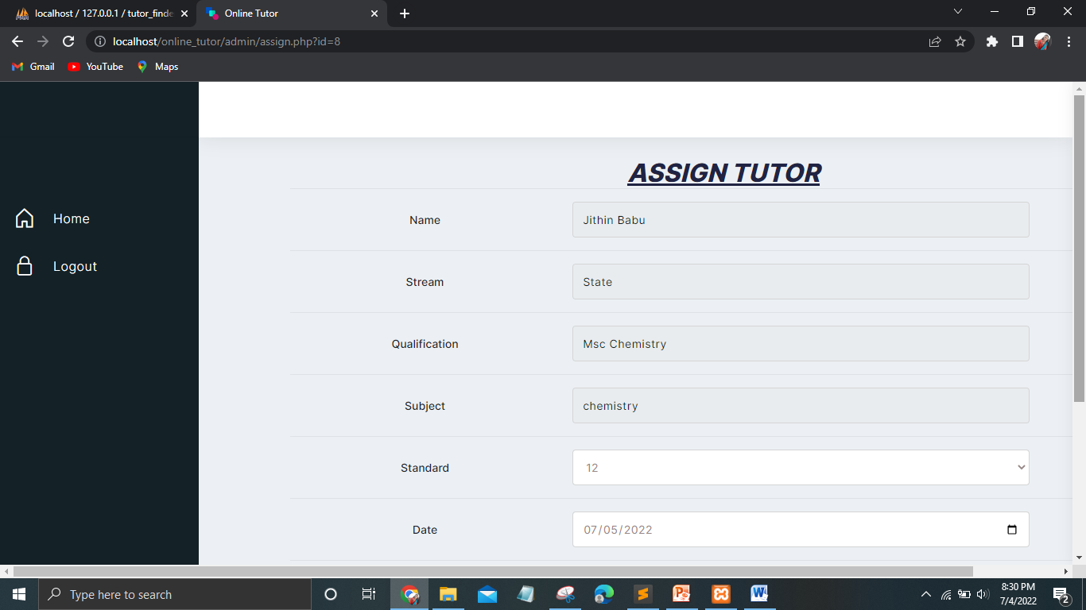

**UNASSIGNED LIST**

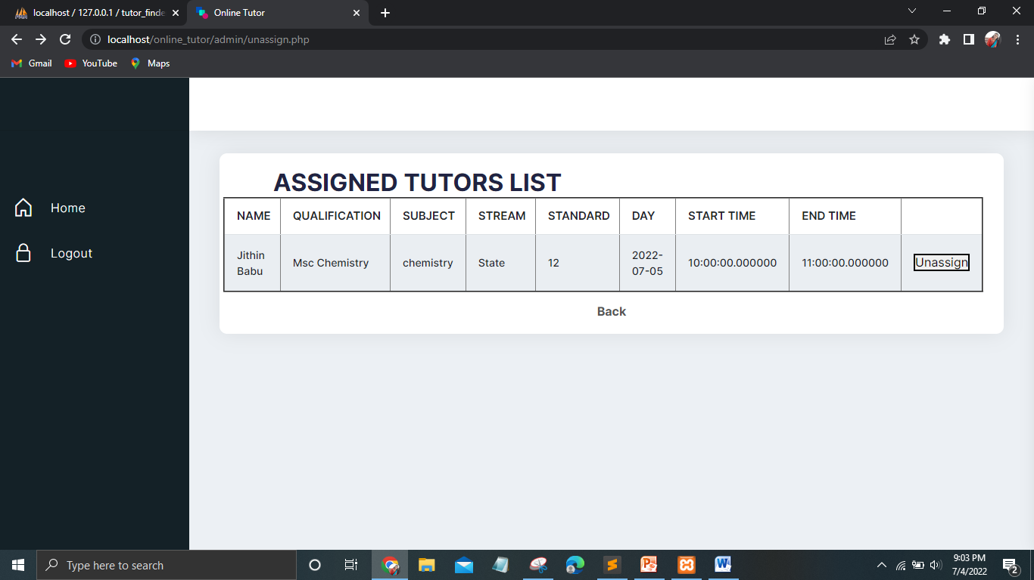

**Tutor Home Page**

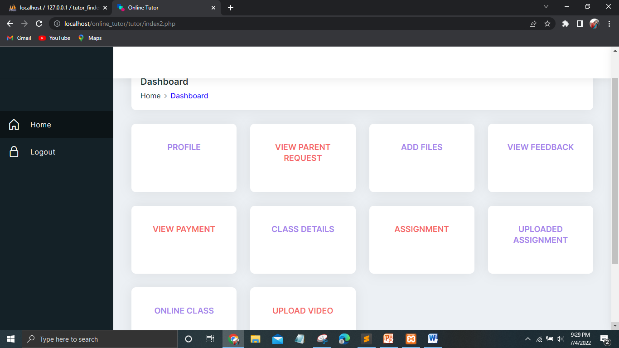

**PROFILE PAGE**

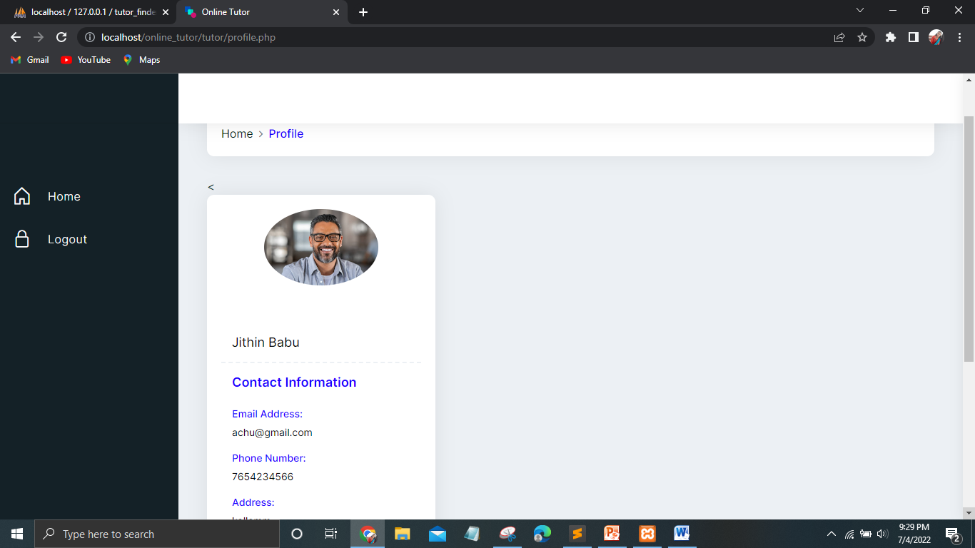

**ADDING NOTES**

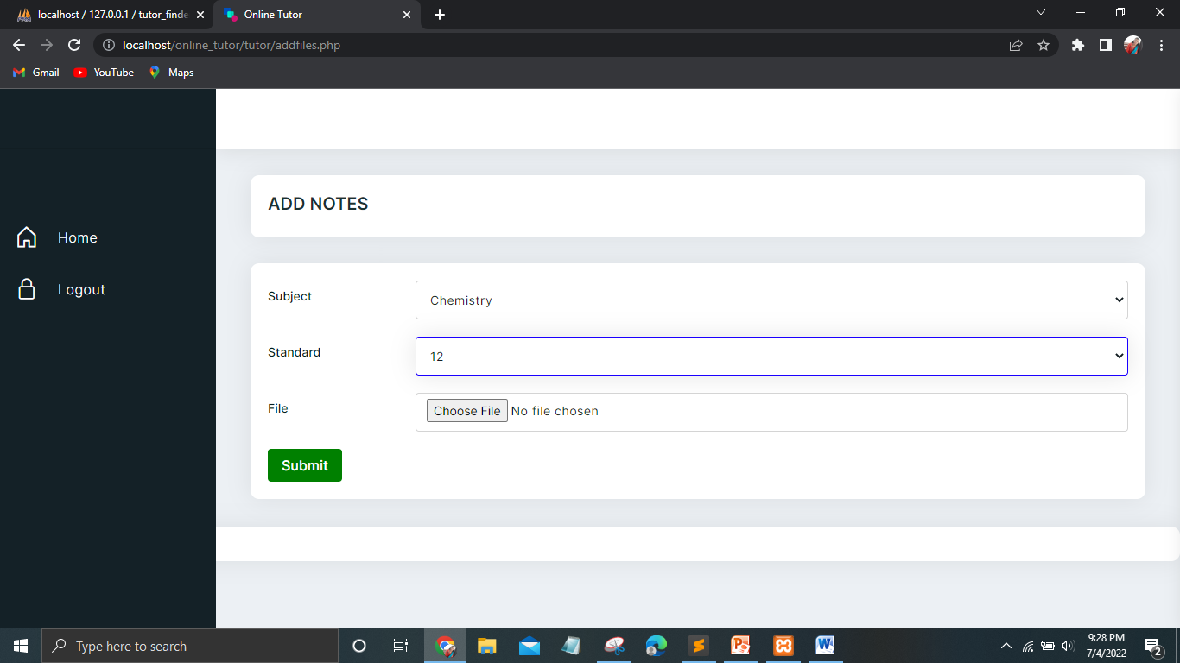

**ADDING ASSIGNMENT DETAILS**

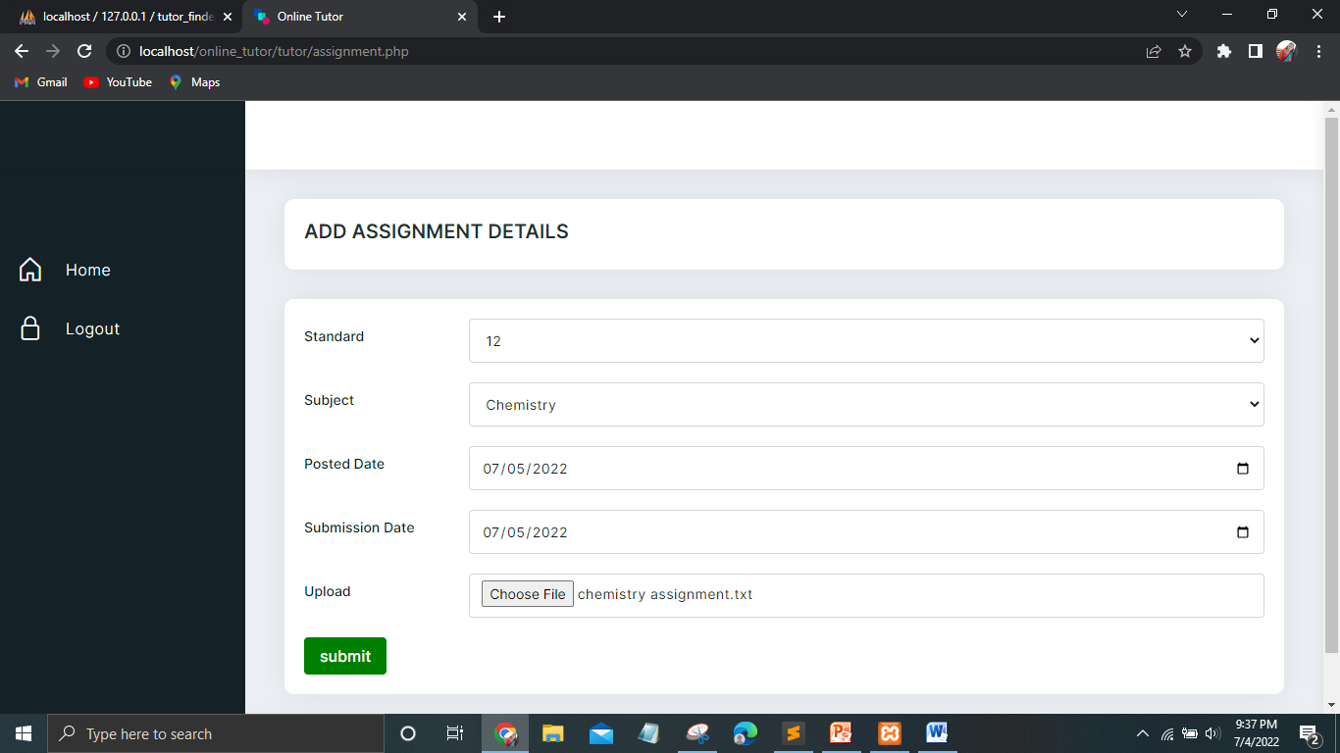

**UPLOAD DEMO VIDEOS**

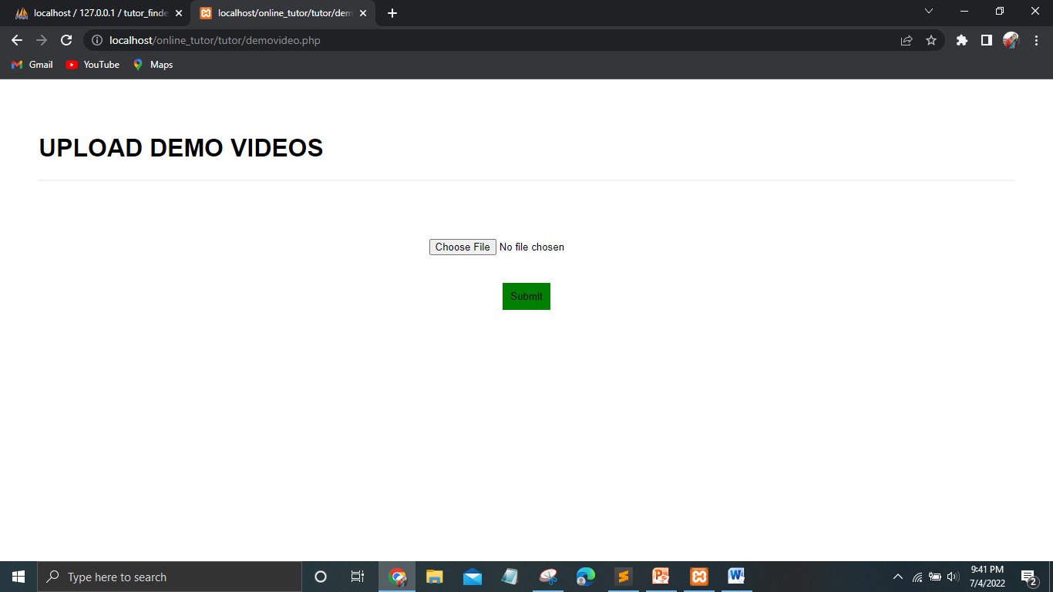

**ADD CLASS DETAILS**

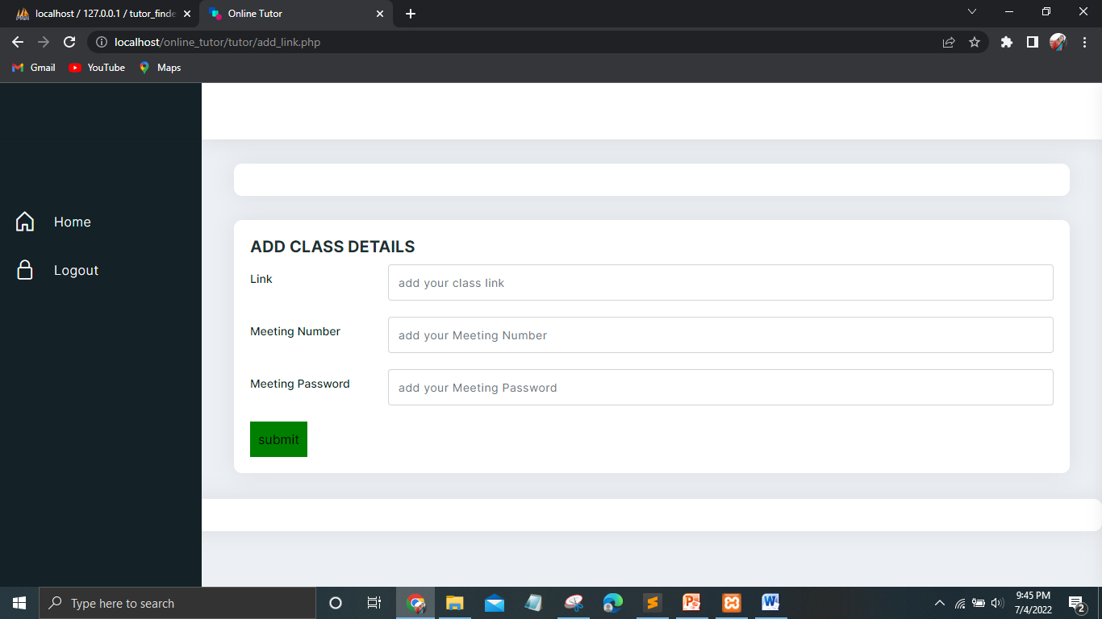

**VIEW PARENT REQUEST PAGE**

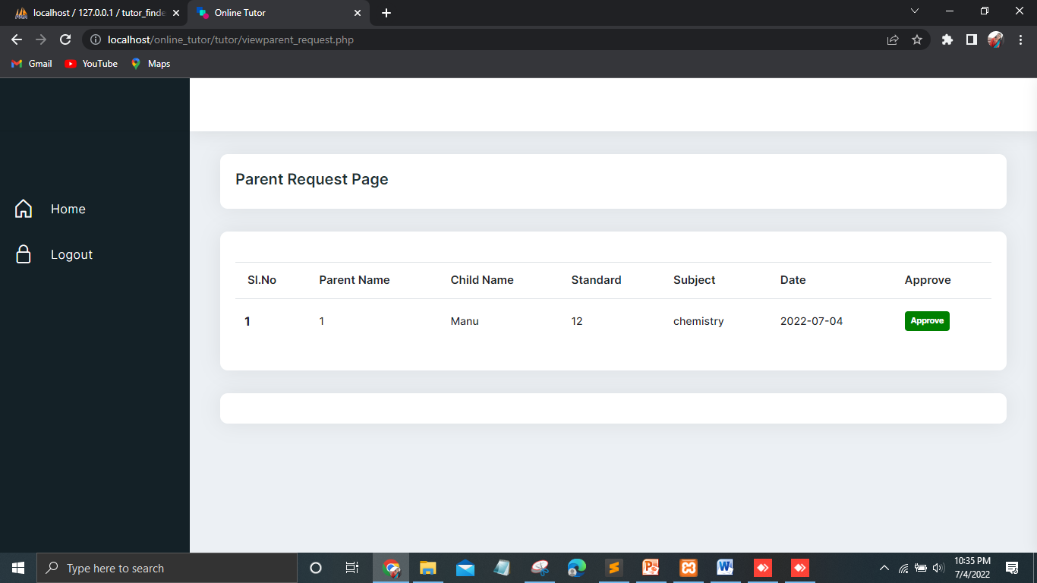

**VIEW SCHEDULE LIST**

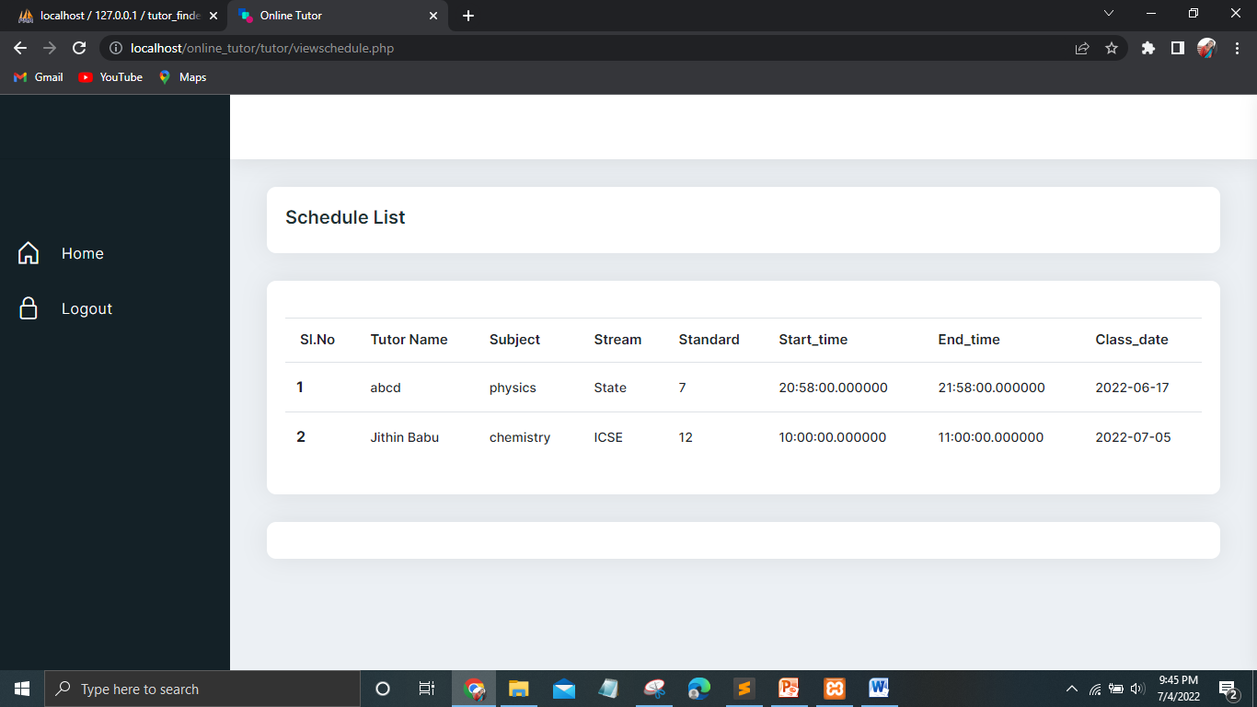

**VIEW FEEDBACK**

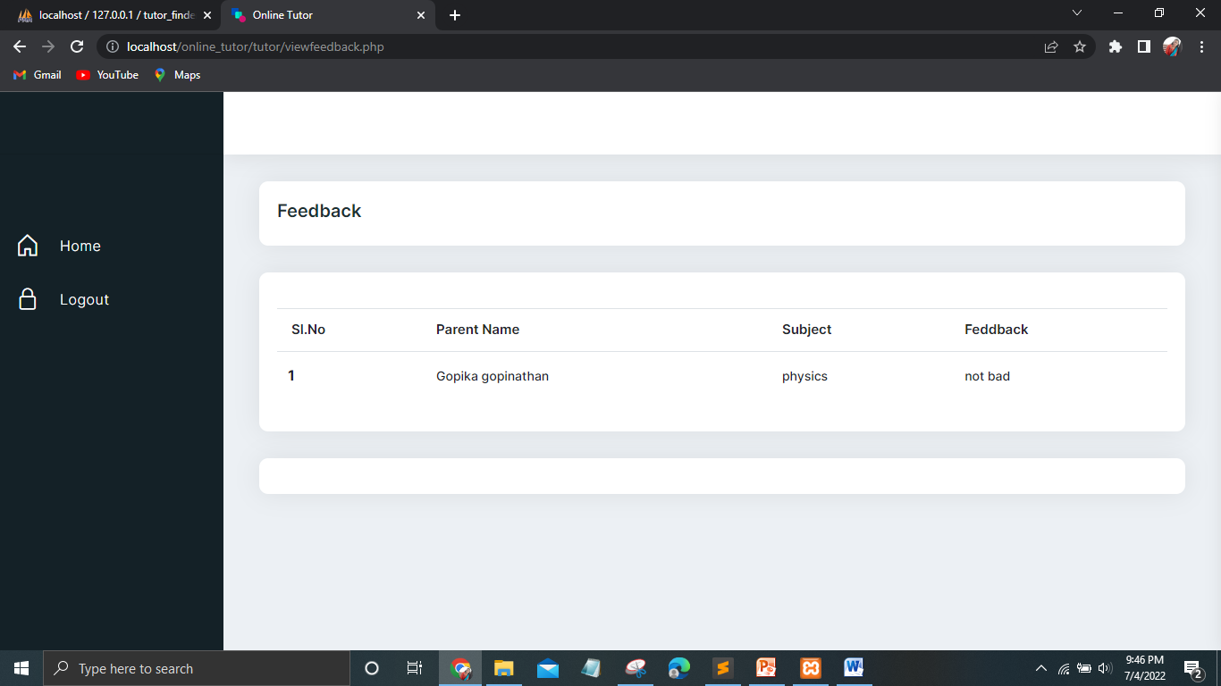

**USERS HOME PAGE**



**PARENT PROFILE PAGE**

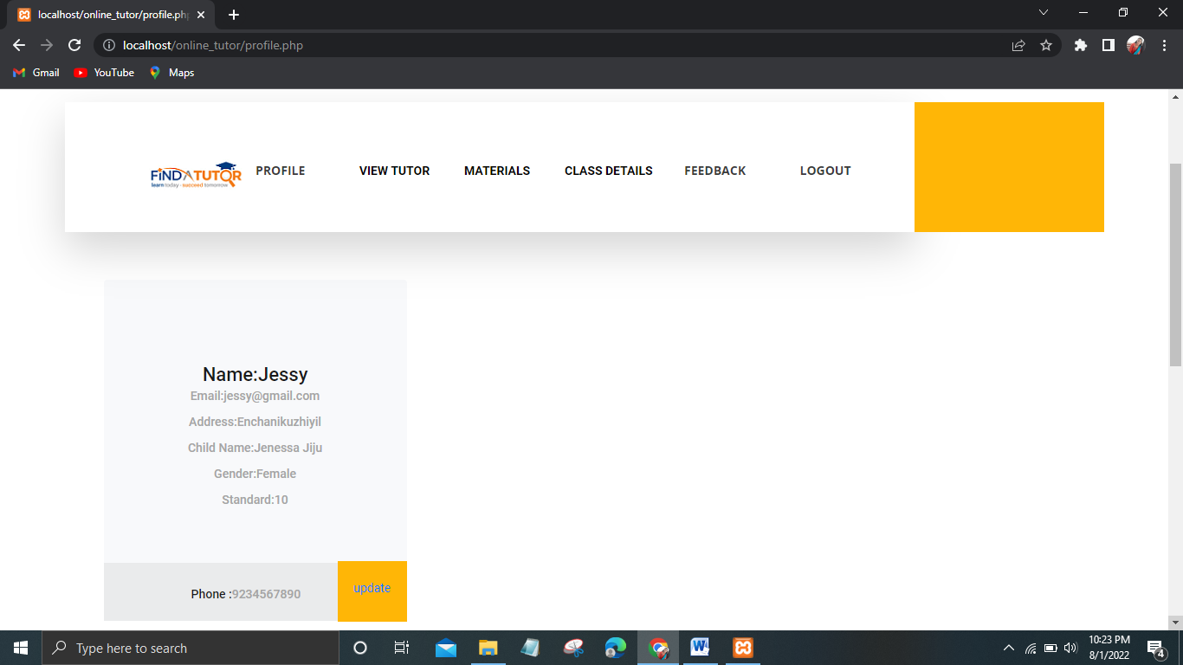

**VIEW TUTORS**



**REQUEST PAGE**

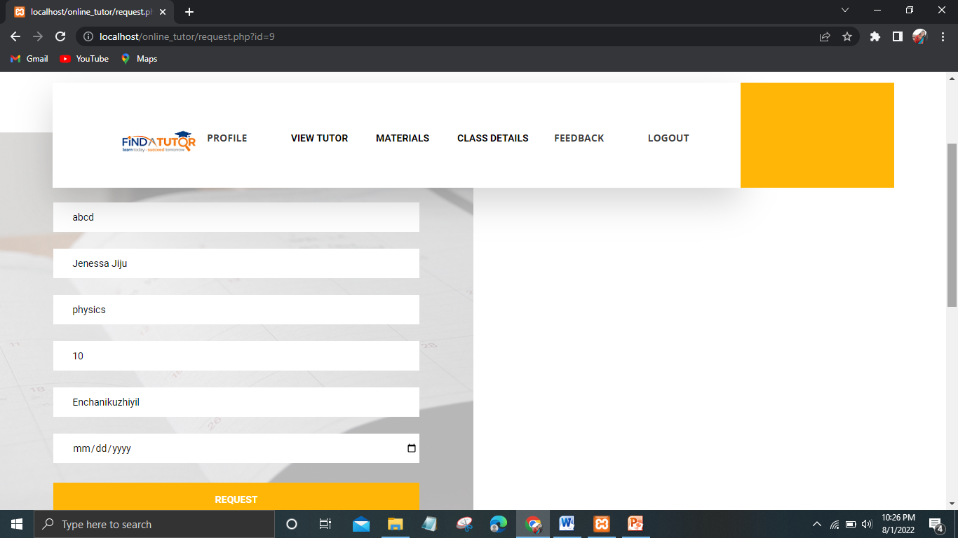

**VIEW APPROVED REQUEST PAGE**

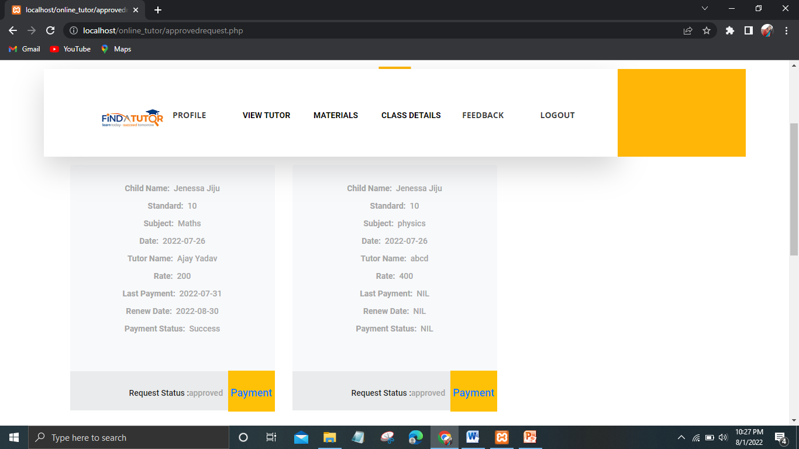

**VIEW NOTES**

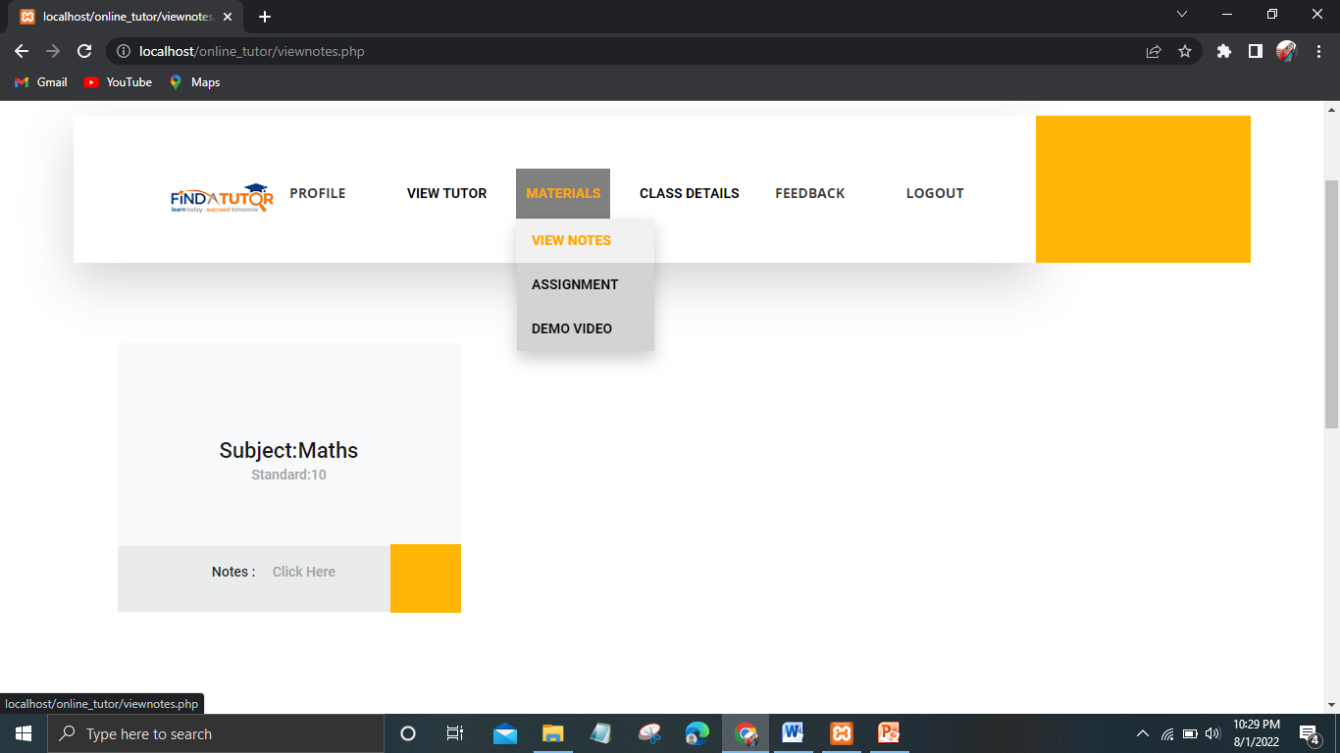

**VIEW ASSIGNMENT**

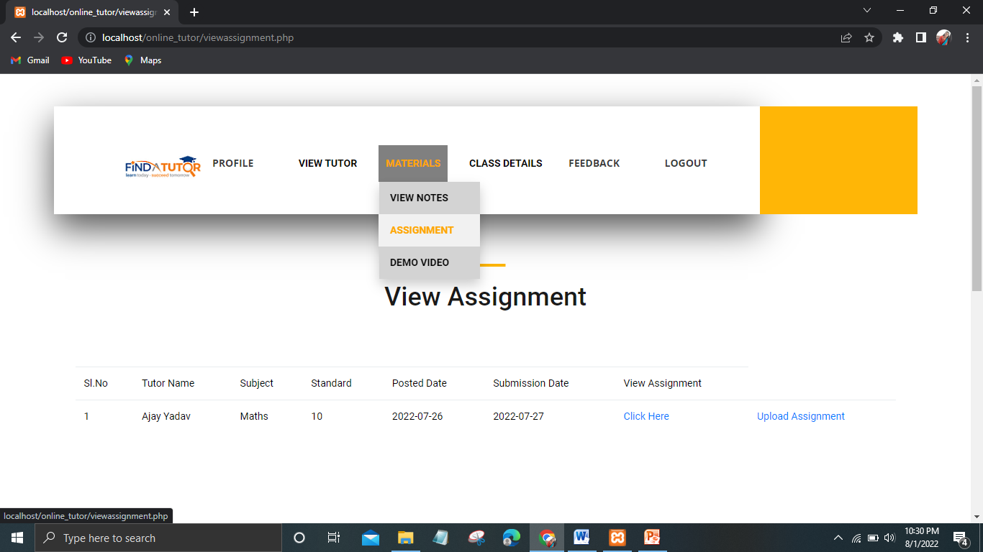

**VIEW DEMO VIDEOS**

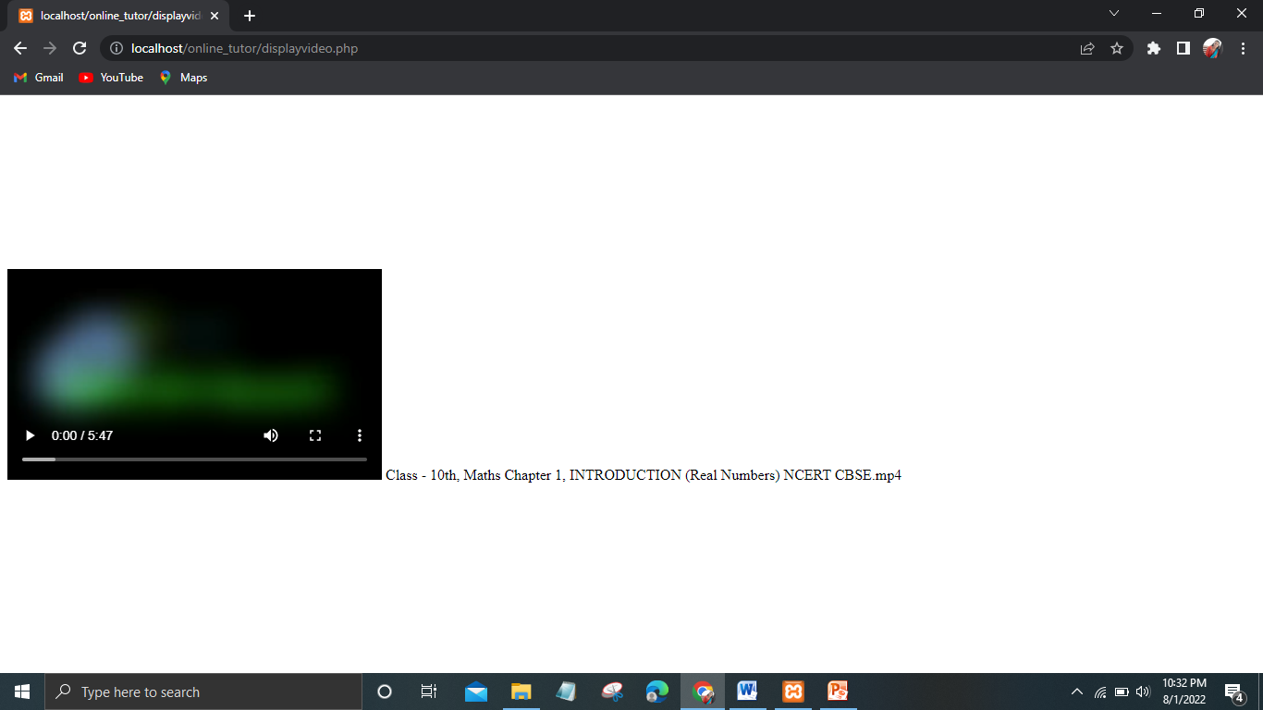

**VIEW CLASS SCHEDULES**

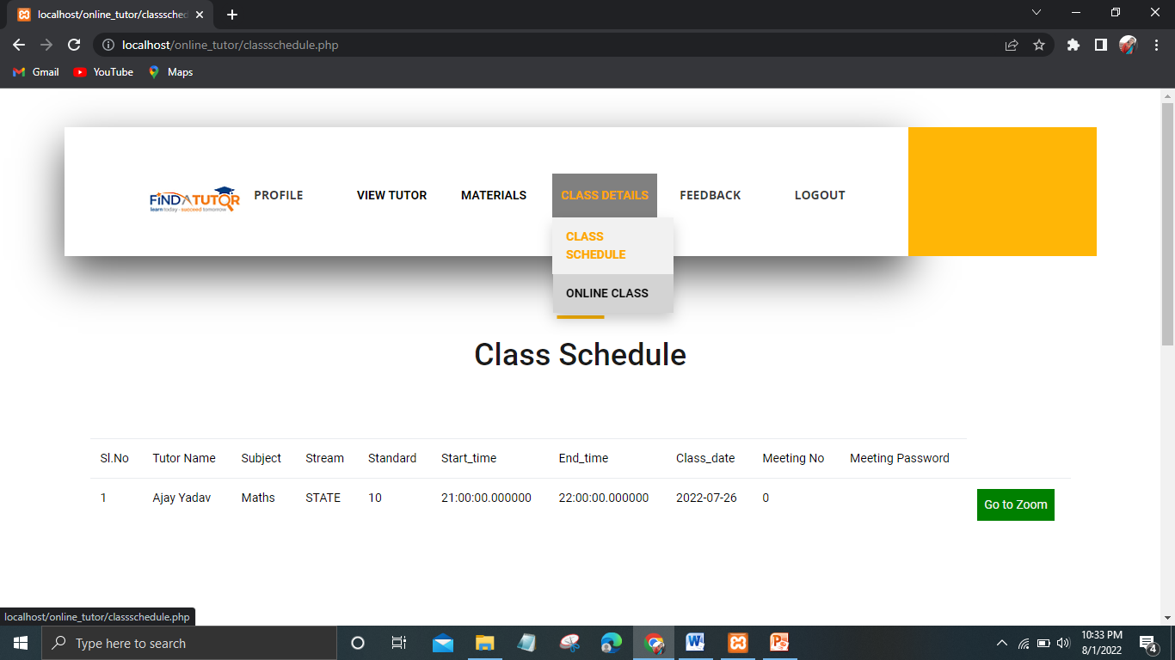

**ONLINE CLASS**

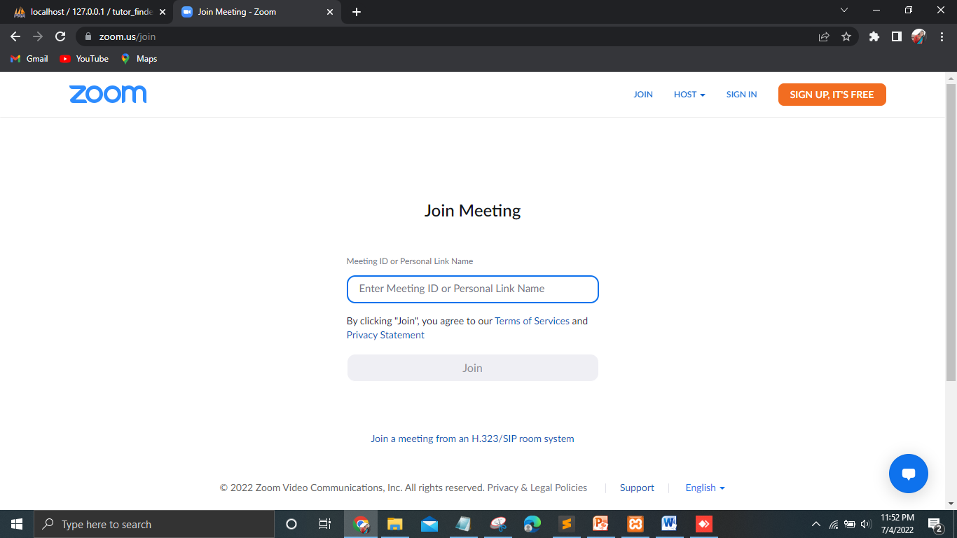

**PAYMENT PAGE**

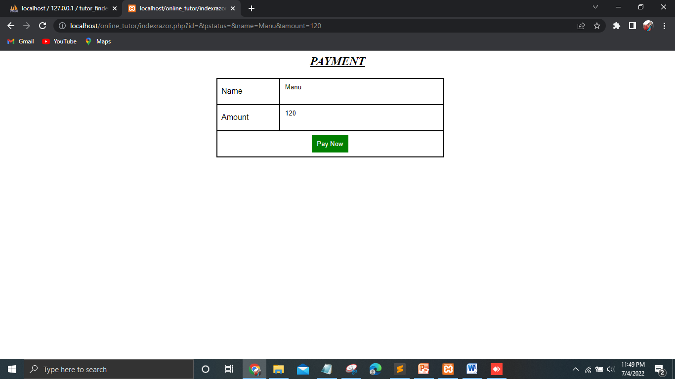

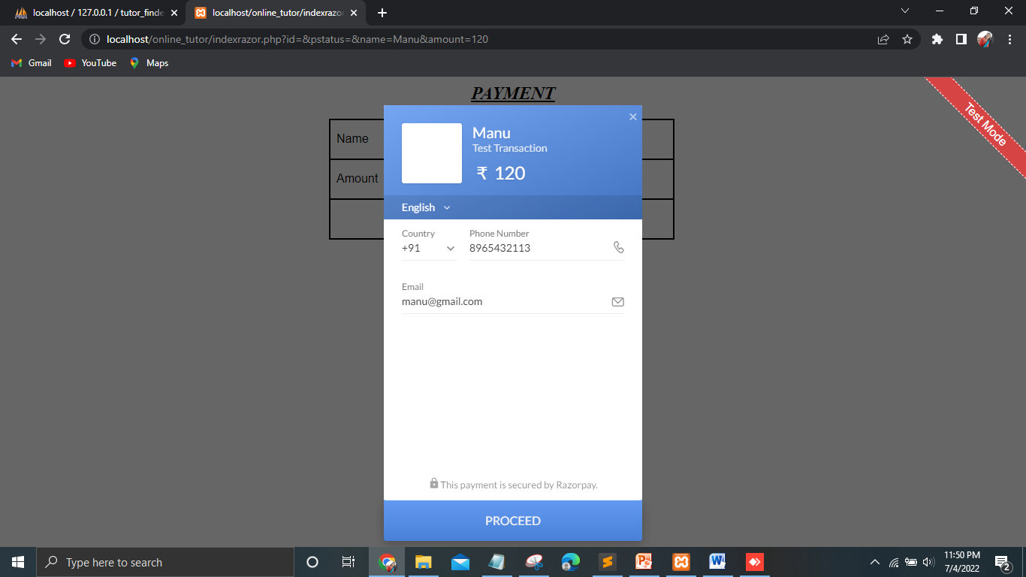

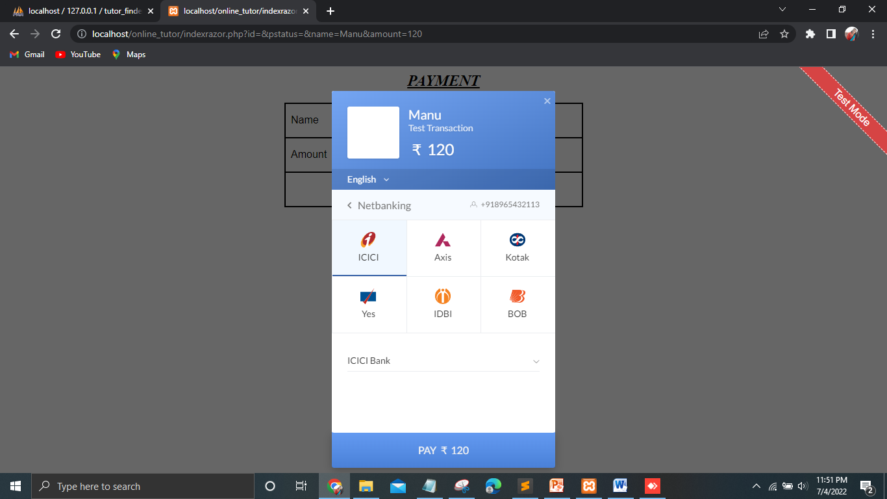

**12.2 APPENDIX-B: SAMPLE CODE**

**Login.php**

<?php

include("header.php");

?>

<div class="register">

<div class="container-fluid">

<div class="row row-eq-height">

<div class="col-lg-6 nopadding">

<div class="search_section d-flex flex-column align-items-center justify-content-center">

<div class="search_background" style="background-image:url(images/search_background.jpg);"></div>

<div class="search_content text-center">

<h1 class="search_title">Login Here</h1>

<center>

<form id="search_form" action="check.php" class="search_form" method="post">

<input id="search_form_degree" class="input_field search_form_degree" type="email" name="email" placeholder="username">

<input id="search_form_degree" class="input_field search_form_degree" type="password" name="password" placeholder="password">

<br><br>

<select style="color:#978888!important" name="type" class="form-control">

<option>--Select UserType--</option>

<option>Admin</option>

<option>Tutor</option>

<option>Parent</option>

</select>

<button id="search_submit_button" type="submit" name="submit" class="search_submit_button trans_200" value="Submit">Login</button>

</form>

</center>

</div>

</div>

</div>

</div>

</div>

</div>

<?php

include("footer.php");

?>

**Tutor_registration.php**

<?php

include("header.php");

?>

<div class="register">

<div class="container-fluid">

<div class="row row-eq-height">

<div class="col-lg-6 nopadding">

<div class="search_section d-flex flex-column align-items-center justify-content-center">

<div class="search_background" style="backgroundimage:url(images/search_background.jpg);"></div>

<div class="search_content text-center">

<h1 class="search_title">Register Here</h1>

<center>

<form id="search_form" class="search_form" enctype="multipart/form-data"method="post">

<h3 style="text-align: left;color:#978888!important"> Enter Name </h3>

<input id="search_form_name" class="input_field search_form_name" type="text" name="name" required="required" data-error="Enter Name">

<h3 style="text-align: left;color:#978888!important"> Email </h3>

<input id="search_form_category" required class="input_field search_form_category" type="email" name="email" required="required" data-error="Enter Email">

<h3 style="text-align: left;color:#978888!important"> Address </h3>

<input id="search_form_degree" required class="input_field search_form_degree" type="text" name="address" required="required" data-error="Enter Address">

<h3 style="text-align: left;color:#978888!important"> Phone Number </h3>

<input id="search_form_degree" required class="input_field search_form_degree" type="text" name="phone" pattern="[56789][0-9]{9}" required="required" data-error="Enter phone number">

<h3 style="text-align: left;color:#978888!important"> Password </h3>

<input id="search_form_degree" required class="input_field search_form_degree" type="password" name="password" pattern="(?=.*\d)(?=.*[a-z])(?=.*[A-Z]).{8,}" required="required" data-error="Enter Password">

<h3 style="text-align: left;color:#978888!important"> Qualification </h3>

<input id="search_form_degree" required class="input_field search_form_degree" type="text" name="qualification" required="required" data-error="Enter Qulification" >

<h3 style="text-align: left;color:#978888!important"> Experience </h3>

<input id="search_form_degree" required class="input_field search_form_degree" type="text" name="experience" required="required" data-error="Enter Experience">

<h3 style="text-align: left;color:#978888!important"> Fees </h3>

<input id="search_form_degree" required class="input_field search_form_degree" type="text" name="rate" required="required" data-error="Enter rate">

<h3 style="text-align: left;color:#978888!important"> Gender </h3><select style="color:#978888!important" name="gender" required class="form-control">

<option >--Select Gender--</option>

<option value="Female">Female</option>

<option value="Male">Male</option>

<option value="Others">Others</option>

</select><br>

<h3 style="text-align: left;color:#978888!important"> Subject </h3>

<?php

$con=mysqli_connect("localhost","root","","tutor_finder");

$q="SELECT subject from subject";

$qr=mysqli_query($con,$q);

?>

<select style="color:#978888!important" name="subject" required class="form-control">

<option >--Select Subject--</option>

<?php

while($res=mysqli_fetch_assoc($qr)){?>

<option value="<?php echo $res['subject']; ?>"><?php echo $res['subject']; ?>

</option><?php } ?></select><br>

<h3 style="text-align: left;color:#978888!important"> Stream </h3><select style="color:#978888!important" name="stream" required class="form-control">

<option >--Select Stream--</option>

<option value="ICSE">ICSE</option>

<option value="CBSE">CBSE</option>

<option value="STATE">STATE</option>

</select><br>

<input id="search_form_degree" required class="input_field search_form_degree" type="hidden" value="pending" name="status" placeholder="status">

<h3 style="text-align: left;color:#978888!important"> Image </h3>

<input id="search_form_degree" class="input_field search_form_degree" type="file" name="image" placeholder="image">

<button id="search_submit_button" type="submit" name="submit" class="search_submit_button trans_200" value="Submit">Register</button>

</form>

</center>

<?php

$con=mysqli_connect("localhost","root","","tutor_finder");

if(isset($_POST['submit'])){

$a=$_POST['name'];

$b=$_POST['email'];

$c=$_POST['phone'];

$e=$_POST['address'];

$f=$_POST['qualification'];

$g=$_POST['experience'];

$h=$_POST['gender'];

$i=$_POST['password'];

$k=$_POST['status'];

$l=$_POST['stream'];

$m=$_POST['rate'];

$n=$_POST['subject'];

if($_FILES['image']['name']){

move_uploaded_file($_FILES['image']['tmp_name'],"images/".$_FILES['image']['name']);

$d=$_FILES['image']['name'];

}

$select = mysqli_query($con, "SELECT * FROM tutor WHERE email = '$b'");

if(mysqli_num_rows($select)){

echo '<script>alert("Email already exists!!!")</script>';

}

else{

echo $i="INSERT INTO tutor(name,email,phone,address,qualification,experience, gender, password,status,image,rate,stream,subject)VALUES ('$a','$b','$c','$e','$f','$g','$h','$i','$k','$d','$m','$l','$n')";

$res=mysqli_query($con,$i);

if($res)

{

//echo $res;

echo '<script>alert(" Succesfully Register!")</script>';

}

}

}

?>

</div> </div>

</div></div>

</div></div>

<?php

include("footer.php");

?>